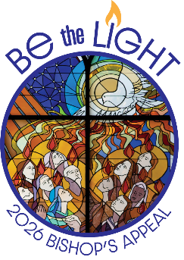
May ___, 2026
«Addressee»
«Address_line_1»
«City» «State» «ZIP_Code»

“…your light must shine before others, that they may see your good
deeds and glorify your heavenly Father.” – Matthew 5:16

Dear <<Salutation>>,

These words call each of us to Be the Light by sharing Jesus through our actions, our compassion, and our generosity. One of the most powerful ways we do this together is through our support of the Bishop’s Appeal at <<Parish Name>>.

Through your participation in the Appeal, you help bring the light of Jesus to individuals and families throughout northeastern Wisconsin. Our parish has raised $<<Amt Given>> toward our goal of $<<Goal>>. Your dedication shows what it means to be a community grounded in faith, service, and love.

Your generosity has a meaningful impact. The Bishop’s Appeal provides essential support for diocesan ministries that strengthen our parish. Deacons are formed to walk with parishioners and share Christ’s presence. Catechists and Catholic school teachers attend diocesan formation days, so they are equipped with the knowledge and tools they need to teach children about Jesus. Catholic Charities accompanies those in need of Christ’s love through mental and financial health resources. Light is shining everywhere!

I am inspired by the generosity of our parish family at <<Parish Name>>. Your gifts share Jesus’ love. Please consider making your gift of $<<Ask 1>> today. Thank you, and may God bless you.

Yours in Christ,

<<Signature>>

<<Typed Name>>


P.S. Help us reach our Bishop’s Appeal goal of $<<Goal>>. Currently, our parish
has received gifts totaling $<<Amt Given>>. To make your gift today, visit www.catholicfoundtiongb.org/give or scan the QR code to the right.

Catholic Foundation for the Diocese of Green Bay, Inc.
P.O. Box 23001 • Green Bay, WI 54305-3001 • 920-272-8008 • bishopsappeal@cfgbwi.org • www.catholicfoundationgb.org

