2026 Bishop’s Appeal - Pastor Emails

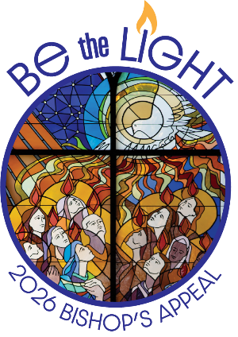

February 9, 2026

Subject Line: Be the Light – Support the Bishop’s Appeal

Dear <<First Name>>,

As I look around our diocese, I see the light of Christ shining in so many ways: through acts of kindness, moments of prayer, and the generosity of people like you. Our parish plays a vital role in this mission, and now more than ever, we are called to Be the Light for others.

You should have received a letter from Bishop Ricken inviting you to support the 2026 Bishop’s Appeal. The ministries funded by the Appeal extend far beyond the walls of <<Parish Name>>. Your gifts are reaching those who are struggling, guiding those seeking faith, and forming future leaders in our Church.

If you have given to the Bishop’s Appeal in the past, thank you for your faithful support. And if you have never made a gift before, I invite you to consider making your first gift this year. Every contribution—large or small—helps bring Christ’s love to people across northeastern Wisconsin.

Another meaningful way to support the Bishop’s Appeal is through the Crozier Society. More than 3,700 Catholics are part of this special community of disciples who help strengthen the mission of our Church. Crozier members are invited to the annual Bishop’s Appreciation Mass and Luncheon and the Spring Mass, and they receive The Little Books series during Advent, Lent, and Easter to enrich their prayer life throughout the year.
If you are able, please consider a gift of $500 or more to become a Crozier Society member. Growing the Crozier Society helps us expand the reach of the Bishop’s Appeal and the good
it accomplishes. Please know whatever you are able to give is greatly appreciated.

I’m asking for your help. Our parish is a beacon of hope and generosity, and I believe we can exceed our goal this year. Your gift will help people encounter Christ’s love through Catholic Charities, faith formation programs, and so much more.

Please prayerfully consider making your gift today. You can return your pledge in the blue envelope included with Bishop Ricken’s letter, or make your gift online at http://www.catholicfoundationgb.org/give.

Together, we can shine Christ’s light throughout northeastern Wisconsin.

May God bless you and your family, and thank you for being a light in our parish and beyond.

Gratefully,

<<Pastor/Pastoral Leader Name>>

Week 4 – February 23, 2026

Electronic communications are a particularly important means of staying in touch with parishioners. They reinforce your messages to those who are attending Mass and other parish activities in person.

The following email is offered as a guide for crafting your own parish emails and newsletters. Please note that when modifying, the giving link must remain the same.

Please send this email on or around Monday, February 23. We recommend sending this as a stand-alone email and not including it in the regular parish email.



Subject Line: Be the Light This Lent

Dear <<First Name>>,

Lent is a sacred season inviting us to slow down, reflect, and renew our hearts in Christ. As we walk this journey together, I’m filled with gratitude for the light you bring to our parish and community.

Thanks to your prayers and support, our parish’s Bishop’s Appeal is off to a strong start. Your generosity is a beautiful reflection of your faith, and it’s making a real difference.

The Bishop’s Appeal supports Catholic Charities as they walk with couples looking to grow their family through adoption, nurture faith through parish faith formation programs and Catholic schools, and form disciples through Entrust Retreats who carry Christ’s light into the world. Your gift helps make all of this possible. Thank you!

If you have already given to the Bishop’s Appeal, please know how grateful I am. If you have not yet had the opportunity to participate, I invite you to consider making your first gift this year. Every contribution truly helps us Be the Light for others.
You can make your gift in one of two simple ways:
Give online at http://www.catholicfoundationgb.org/give

Return the blue envelope and gift card included with Bishop Ricken’s letter

Every gift matters. Every act of generosity helps us Be the Light for others. Please know whatever you are able to give is greatly appreciated.

May God bless you and your loved ones this Lent. Please continue to pray for our parish and for all those touched by the Bishop’s Appeal.

Gratefully,

<<PASTOR/PASTORAL LEADER NAME>>

P.S. Please make your gift today at www.catholicfoundationgb.org/give

Week 6 – March 9, 2026

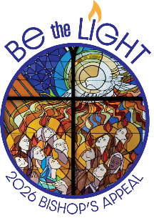

Subject Line: Your Light is Making a Difference!

Dear <<First Name>>,

The 2026 Bishop’s Appeal is off to a tremendous start!

If you’ve already made your gift, thank you! Your generosity is a light that brings hope and healing to so many.

Will you please say a prayer right now for the continued success of our Appeal? Join me in saying the following prayer:

A Prayer for the Bishop’s Appeal
Loving and gracious God,
You are the source of every blessing and the giver of all good gifts.
As we journey through this holy season of Lent, open our hearts to Your grace.
Bless the Bishop’s Appeal and all those who benefit from its ministries.
Strengthen our parish family in generosity, compassion, and faith.
May our gifts help others encounter Christ’s love, and may we always strive to Be the Light in
our communities.
We ask this through Christ our Lord. Amen.
So far, <<Number of Families who gave to BA26>> families have given in our parish, raising a total of $<<Amount of Money raised in parish>>. What a beautiful testament to <<Parish Name>>’s faith and compassion.

As we continue our Lenten journey, I’m reminded of the everyday blessings happening around us. I see it in parish faith formation students, growing in faith and joy. I see it in the catechists who guide them, whose training is made possible by your gift to the Bishop’s Appeal.

If you have already given, thank you. If you have not yet had the chance, I invite you to consider making your first gift this year. Your generosity truly changes lives. Please know whatever you are able to give is greatly appreciated.
If you haven’t yet made your gift, it’s simple:
Give online at http://www.catholicfoundationgb.org/give.
Return your pledge in the blue envelope from Bishop Ricken’s letter.
Your generosity helps us Be the Light in our community and beyond. Thank you for being part of this mission.
God bless you and your family this Lent.
Gratefully,
(PASTOR/PASTORAL LEADER NAME)

