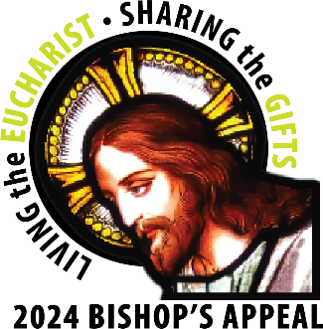
May 24, 2024
«Addressee»
«Address_line_1»
«City» «State» «ZIP_Code»

“Make disciples of all nations, baptizing them in the name of the Father, and of the Son, and of the Holy Spirit, teaching them to observe all that I have commanded you.” – Matthew 28:16-20

Dear <<Salutation>>,

“Make disciples.” The mission we have is clear. We are to bring Jesus to all we meet and share His love with them. We can do this by Living the Eucharist and Sharing the Gifts with our brothers and sisters at <<Parish Name>> and with others throughout northeastern Wisconsin. Through the Appeal, we can share Jesus with more people.

Our parish has raised <<Ask 1>> toward our Bishop’s Appeal goal of <<Goal>>. At <<Parish Name in Letter>>, we are a vibrant community ready to share our gifts and Christ’s love with all we meet and serve. Thank you for being a part of our parish family.

The Bishop’s Appeal provides many diocesan ministries that help our parish. These ministries support the future of our Church and help many people in need. Your gift forms the youth of our parish in the Catholic faith. Educators in our faith formation programs receive the training and tools they need to lead our young people to discover Christ. For those struggling with mental health issues, financial stress, or marriage difficulties, Catholic Charities offers counseling to individuals and families. Gifts are everywhere.

Thank you for your past support of the Bishop’s Appeal. I am blessed to witness the generosity of our parishioners at <<Parish Name>>. When you give to the Appeal, you are Living the Eucharist and Sharing the Gifts. Please consider making a gift of <<Ask 1>> to the Appeal today. Thank you, and may God bless you.

Yours in Christ,

<<Signature>>

<<Typed Name>>

P.S. Help us reach our Bishop’s Appeal goal of <<Goal>>. Currently, our parish has received gifts totaling <<Amount Given>>. To make your gift today, visit www.catholicfoundtiongb.org/give.
Catholic Foundation for the Diocese of Green Bay, Inc.
P.O. Box 23001 • Green Bay, WI 54305-3001 • 920-272-8008 • bishopsappeal@cfgbwi.org • www.catholicfoundationgb.org

