Friday, February 2, 2024
- 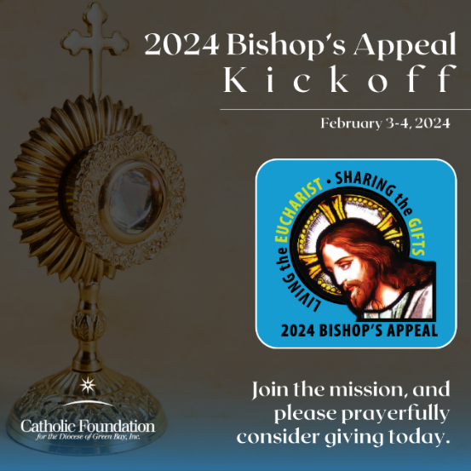
- CAPTION: The 2024 Bishop’s Appeal kicks off in the Diocese of Green Bay this weekend! Join us in Living the Eucharist and Sharing the Gifts. Please make a gift today at www.catholicfoundationgb.org/give.

Tuesday, February 5, 2024
- 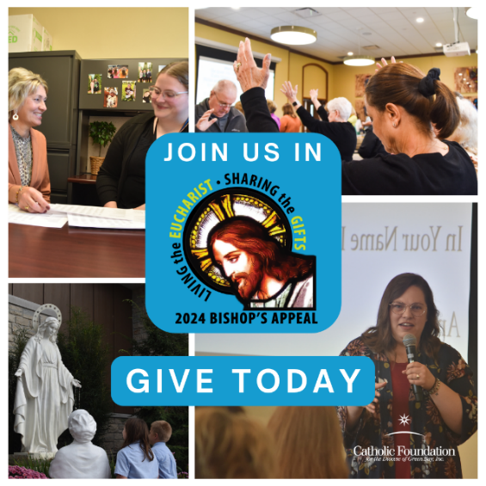
- CAPTION: We are Living the Eucharist and Sharing the Gifts throughout the Diocese of Green Bay. Join us, and please make your gift to the 2024 Bishop's Appeal!

Thursday, February 8, 2024
- CAPTION: How will YOU respond? When you share your gifts to the Bishop's Appeal, you support essential diocesan ministries that share Jesus with others. Answer "yes," and give to the Appeal today!

Sunday, February 11, 2024
- Share the video: https://www.catholicfoundationgb.org/video
- CAPTION: Jesus is here in the Diocese of Green Bay. See how the Bishop’s Appeal supports essential ministries that share Jesus’ love throughout northeastern Wisconsin. Together, we are Living the Eucharist and Sharing the Gifts!

Tuesday, February 13, 2024
- 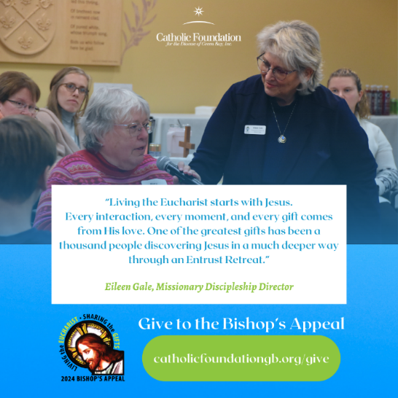
- CAPTION: Through the Bishop’s Appeal, you help make these diocesan Entrust Retreats possible. Please give to the 2024 Bishop's Appeal today to support this and more essential ministries in the Diocese of Green Bay.
Wednesday, February 14, 2024
- Post the Bishop Ricken social promo clip: https://vimeo.com/909195441
- CAPTION: The Bishop’s Appeal helps people discover Jesus in our Catholic schools, faith formation programs, and other diocesan ministries. Join Bishop Ricken, and make your generous pledge to the Bishop’s Appeal today.

Thursday, February 15, 2024
- CAPTION: Entrust sets hearts on fire for the Lord! You help make these Entrust Retreats possible through your generosity. Give to the 2024 Bishop's Appeal to support this and other essential diocesan ministries today.

Saturday, February 17, 2024
- Share the Eileen and Entrust social media promo clip: https://vimeo.com/909223297
- CAPTION: Your gift to the Bishop’s Appeal has helped form over 1,000 missionary disciples in the Diocese of Green Bay. Support the Entrust retreat, and make your gift to the Appeal today!

Tuesday, February 20, 2024
- CAPTION: The Parish Life & Family Mission Team offers parishes best practices in operations, family life ministry, and liturgy. Your support of the Bishop's Appeal supports your parish and brings more people to Jesus.

Wednesday, February 21, 2024
- Post the Gerard social media promo clip: https://vimeo.com/909212324
- CAPTION: Sunday worship is essential to deepen your relationship to Jesus. Your gift to the Bishop’s Appeal helps the Evangelization & Discipleship Mission Team enhance worship opportunities for your parish and other parishes throughout northeastern Wisconsin. Help your parish, and make your gift today!

Thursday, February 22, 2024
- 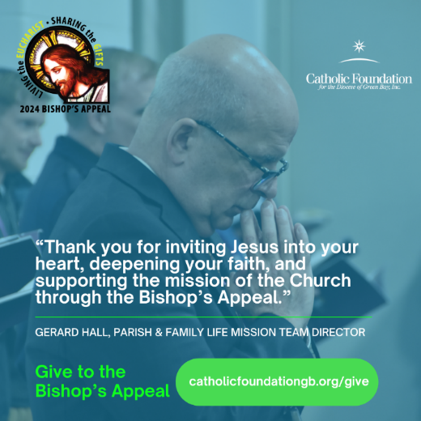
- CAPTION: Thank you for supporting the 2024 Bishop's Appeal. It's thanks to your open heart and deep faith that we can grow the Church here in northeastern Wisconsin.

Tuesday, February 27, 2024
- 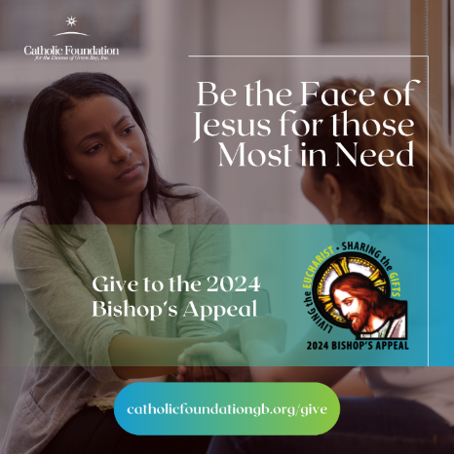
- CAPTION: Just as Jesus is there for each of us every day – Catholic Charities is there as the face of Jesus to those most in need. Your gift to the Bishop's Appeal supports this ministry.

Wednesday, February 28, 2024
- Post the Karmen and Catholic Charities social media promo clip: https://vimeo.com/909204520
- CAPTION: Your gift to the Bishop’s Appeal supports Catholic Charities counselors as they share Jesus with those struggling with depression, anxiety, financial hardship, marriage difficulties, and more. Help Catholic Charities be the face of Jesus for those most in need. Give your gift today!

Thursday, February 29, 2024
- CAPTION: Your gift supports this essential ministry and shares Jesus with others. Please give to the 2024 Bishop's Appeal today at catholicfoundationgb.org/give.

Tuesday, March 5, 2024
- 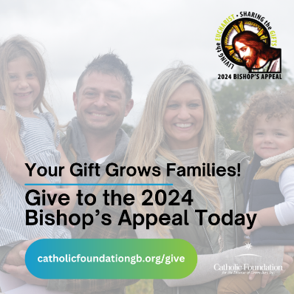
- CAPTION: Stevie and Michelle grew their family through the loving adoption ministry at Catholic Charities. Your gift creates and strengthens families!

Thursday, March 7, 2024
- CAPTION: Join Bishop Ricken, and make your pledge to the 2024 Bishop's Appeal today! Give your gift at catholicfoundationgb.org/give.

Tuesday, March 12, 2024
- 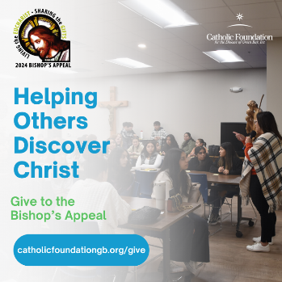
- CAPTION: Faith formation programs help others discover Christ. Your generous support makes it possible for this ministry to grow and serve youth at your parish and across the Diocese of Green Bay.

Thursday, March 14, 2024
- 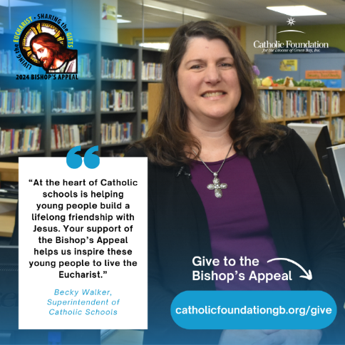
- CAPTION: Your support of the Bishop’s Appeal helps Catholic schools inspire young people to live the Eucharist. Thank you for your generosity!

Saturday, March 16, 2024
- Post the Becky and Catholic schools social media promo clip: https://vimeo.com/909212988
- CAPTION: Your support of the Bishop’s Appeal helps Catholic schools inspire young people to live the Eucharist and bring others to Jesus. Make your gift today to further this essential ministry. Together, we can share Jesus with the youngest members of our Church!

Tuesday, March 19, 2024
- 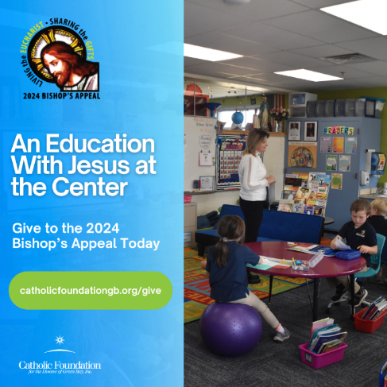
- CAPTION: At the heart of Catholic Schools is helping young people build a lifelong friendship with Jesus. You make this faith-filled education possible through your support of the Bishop's Appeal!

