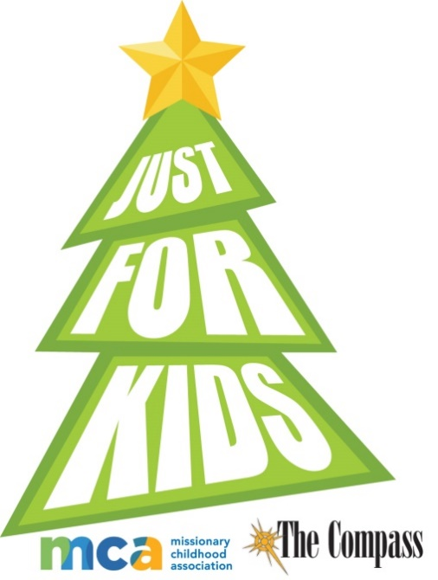
The COMPASS Annual
“Just for Kids”
Christmas Essay/Artwork Contest

Congratulations to Bernadette Langer, a 1st grade home schooler. Bernadette is our 7th winner of the diocesan MCA National Artwork contest winners in six years. What a great accomplishment!
Please honor our Savior’s birth and share your art and writing talents with us this year.

In partnership with World Mission Services, The Compass presents its annual Christmas essay/art contest this year. Three artwork winners from each age group, K-8, will be chosen by a diocesan panel of judges. This winning artwork will be sent to the Missionary Childhood Association National Christmas Artwork Contest. 24 national winners will be selected by MCA and this winning art will appear as e-greeting 2023 Christmas cards at www.missio.org/resources and winners are celebrated in December. All winners will receive a commemorative plaque. One prize winners’ art will become the official Christmas card for the National Director, Monsignor Kieran E. Harrington of the Pontifical Mission Society in the United States.

Entry deadline: December 2, 2022. Send entries to: “Just for Kids” Attn. Just for Kids, c/o The Compass, P O Box 23825, Green Bay WI 54305-3825 or send digitally to compassnews@gbdioc.org and titled “Just for Kids artwork” or “Just for Kids essay.” Local Just for Kids winners will be announced in The Compass’ on Dec. 30, 2022 and posted on The Compass website: thecompassnews.org.

Students must illustrate the 2022 theme: “the Holy Family.” This entry form must accompany all “Just For Kids” artwork. • The illustration must be depicted HORIZONTALLY. Essay theme will be announced in the Oct., 7 issue of The Compass and on thecompassnews.org.

Questions? Please contact Cindy St. Aubin, World Mission Director | 920-272-8192 | wmissions@gbdioc.org

Diocese of Green Bay entry form. Please complete this form; tape or glue stick to the back of your art work or submit it with your digital artwork..
Student name ____________________________________________________________________________________________________________
Please circle: | Boy | Girl | Grade
Please circle: | Catholic School | Parish RE/CCD | Home School

Name of School, Parish or RE

Principal/RE name and email

Teacher name_______________________________________________________________________________________________________________________________________

School or Parish address __________________________________________________________________________________________________

School or Parish telephone # ______________________________________________________________________________________________

Student home address as of September 2022____________________________________________________________________________________________________

Parent/Guardian full name ____________________________________________________________________________________________________________________

Home/Parent/Guardian daytime telephone # as of September 2022 ____________________________________________________________

Parent/Guardian email address_____________________________________________________________________________________________
GUIDELINES:
- The contest is open to young people in grades K-8 All entries must be postmarked and / or received no later than December 2 , 2022
- Each entry (drawing) MUST have this completed entry form taped, glue stick to the back of the drawing or sent digitally with art. DO NOT STAPLE ENTRY FORM TO ARTWORK. DON’T FOLD ARTWORK!
- It is not possible for winning entries to be returned.
ARTWORK SPECIFICATIONS
- Artwork must be on an 8.5” x 11” sheet of WHITE paper — no construction or lined paper. White card stock is okay.
- The illustration must be depicted HORIZONTALLY only.
- Students must illustrate the 2022 theme “the Holy Family”
- Acceptable media includes crayons, pastels, markers, tempera or watercolor paints. NO LEAD or COLORED PENCILS.
- Artwork must be the child’s own. Tracings and direct copies of other art cannot be considered.
HELPFUL HINTS
- Use a lot of eye-catching color. Bolder colors reproduce best. Lightly colored artwork will not be seen when reduced.
- Be sure to erase or cover pencil outlines.
- No text or lettering on the drawing.
- Fill up most of the page, do not let the parts of the drawing get too close to the edges of the paper.
- Make sure facial features on people and animals are bold (e.g. nose, eyes, lips, etc.) to reproduce well.

ESSAY GUIDELINES: See the Oct. 7 issue of The Compass for this year’s question! Not to exceed 60 words.

