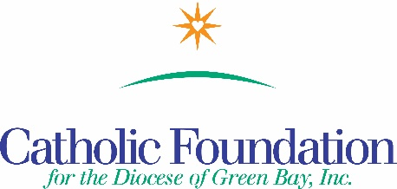

Dear Brothers and Sisters in Christ,

Each Lent, Catholic families across the country unite to put their faith into action through prayer, fasting and almsgiving. Through CRS Rice Bowl, families learn about how our sisters and brothers across the globe overcome hardships like hunger and malnutrition, and how through Lenten alms, we have the power to make the world a better place for all. To serve as a guide for your reflection, I invite you to use CRS Rice Bowl and the World Mission Services Project booklet this Lent.

CRS Rice Bowl provides free resources to bring Lenten spirituality to life for families and school communities, while continuing to connect Catholics in our Diocese with our brothers and sisters in need around the world.

These materials are available in both English and Spanish and are free of charge. Visit crsricebowl.org or crsplatodearroz.org

Journey through the 40 days of Lent with these daily reflections, great meatless recipes and activities included in the CRS Rice Bowl calendar and on the mobile app.

As always, 75% of your contribution to Rice Bowl supports programs to help families and communities overcome the challenges of hunger and poverty. 25% remains in our Diocese to support local hunger and poverty efforts.

World Mission Services Projects Booklet
The Projects booklet consists of 24 short term mission projects. Support a mission project and experience the needs of the global Church. It’s a way to be the hands of Christ. Children can devote their Lenten prayers, fasting and alms to change the lives of those who suffer in poverty.

Perhaps you’ll have a Noah’s Ark project and buy a piglet, chicks or a cow for a school in Uganda, build a latrine for the Dominican Republic, or a community center in Haiti, or help feed children in Bolivia or the Philippines. Your support to the www.catholicfoundationgb.org/projects booklet gives the gift of hope for a better future.

Your Lenten alms change lives globally and in your own community. However you prepare for Easter during your 40-day Lenten journey, may you see the light of hope and be the light of hope to others.

Respectfully,
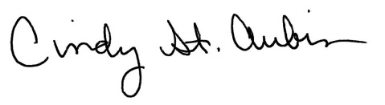
Cindy St. Aubin
World Mission Coordinator
cstaubin@gbdioc.org

