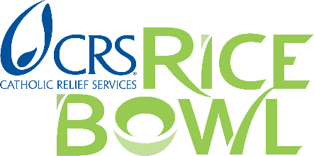
Journey with your family or community around the world while growing in the traditional Lenten practices of prayer, fasting and almsgiving. Whether you are looking for resources for your family, parish, school or diocese, CRS Rice Bowl has what you need to make your Lenten journey a fruitful and faith-filled experience.
Order Free Materials https://www.crsricebowl.org/resources
We are now accepting orders for Lent!
Please place your order for CRS Rice Bowl materials at least three weeks prior to Ash Wednesday. Order online or call 800-222-0025. Materials are available in English and Spanish.
Family Resources Bring Lent to life at home
Use the Lenten calendar, stories, recipes and other resources to enrich your family’s Lenten journey and stay connected with our sisters and brothers around the world.
Parish Resources Enhance your parish’s Lenten experience
Prepare your parish community for Lent using these planning and communication tools. Integrate CRS Rice Bowl into your parish life with liturgical resources for each week of Lent.
Grades 1-8 Resources Lent ideas for younger students
Download lesson plans, videos and activities you need for your child or student.
Grades 9-12 Resources Lent tips for older students
Access prayers, stories, Catholic teaching materials and other resources to supplement your child or student’s Lenten experience.
University Resources Connect your campus community to our global family
Download prayer resources, stories from around the world and more to connect your campus community to our global family this Lent.
Media Resources We have provided resources to help capture and tell the stories of faith in action happening in all 50 states across the U.S. during this season of Lent. For media inquiries ONLY, please contact Brittany Wichtendahl, Public Relations Coordinator, brittany.wichtendahl@crs.org.

