BA21 Pastor Email

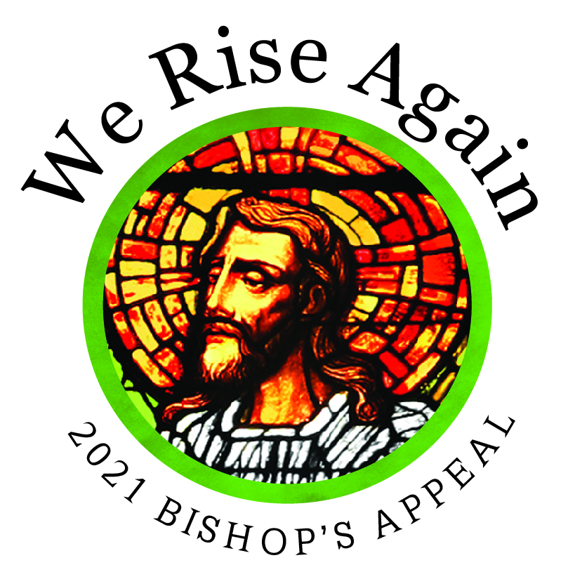

February 15, 2021

Dear <<First Name>>,

The Lenten season is nearly here and as we prepare, it is the perfect time to reflect on the blessings that God has given us. It is also a time for us to pray about how we can bless others.
A beautiful way to share your blessings is by making a gift to the Bishop’s Appeal.

You should have received a letter in the mail from Bishop Ricken asking for your support of the Appeal. We are a community of faith committed to Christ and His work. This work goes far beyond the walls of our parish. While the ministries supported by the Bishop’s Appeal are important every year, today they are perhaps even more necessary.

So, I’m asking you to help me do something special. I want to show how much our parish cares about people in need and prove that whether we’re worshipping together in person or virtually, we are a community of faith and generosity. I know our parish can surpass our goal this year because we know how important the ministries funded by the Bishop’s Appeal are to doing the work of Christ here in northeastern Wisconsin. Together, We Rise Again!

Please prayerfully consider making your gift today by sending your pledge in the blue envelope included with the letter from Bishop Ricken. You can also make your gift online by visiting www.catholicfoundationgb.org/give.

Let’s inspire everyone with our generosity, right here and right now!

God bless you and please continue to pray for the continued health of our community.

Gratefully,

<<Pastor/Pastoral Leader Name>>
Week 4 – March 1st, 2021

As we have learned during the pandemic, electronic communications are a particularly important means of staying in touch with those parishioners who choose to participate virtually. They also reinforce your messages to those who are attending Mass and other parish activities in person.

The following email is offered as a guide for crafting your own parish emails and newsletters. Please note that when modifying, the giving link must remain the same.

Please send this email on or around Monday, March 1. We recommend sending this as a stand-alone email and not including it in the regular parish email.

Dear <<First Name>>,

Our holy Lenten season comes each year to give us pause and allow time for deeper reflection. As I think about the blessings in my life, I am overwhelmingly grateful to be on this path to our Lord with you.

Because of your prayers and support, our parish’s Bishop’s Appeal is off to a strong start. I am not surprised, as our parish has always responded generously when asked. Catholics have always shown great resilience in times of trial, hardships and now, through a pandemic! With the love of our Lord, we are able to rise to these challenges and I am grateful for your continued generosity.

The Bishop’s Appeal supports ministries and programs that serve those in need through Catholic Charities. It provides opportunities to grow for our leaders in Catholic education and faith formation. You make this and so much more possible through your gift. Thank you!

These extraordinary times require an extraordinary response of faith and generosity. If you haven’t yet had the opportunity to give, please prayerfully consider joining me by supporting the 2021 Bishop’s Appeal.

It is fast and simple to share your blessings with our brothers and sisters:

- Make your pledge online at www.catholicfoundationgb.org/give
- Send back the blue envelope that was included with the letter from Bishop Ricken with a check or credit card pledge.

Every gift is important and touches someone’s life. Blessings are multiplied when all of us work together.

May God bless you and your families during this season of Lent. Please continue to pray for the continued health of our community. Together, We Rise Again!

Gratefully,

<<PASTOR/PASTORAL LEADER NAME>>

P.S. Please make your gift today at www.catholicfoundationgb.org/give

Week 6 – March 14, 2021

Dear <<First Name>>,

The 2021 Bishop’s Appeal is off to a tremendous start!

If you have already made your gift, thank you! Will you please say a prayer right now for our continued success? So far xxx families have made their gift and we have raised a total of $x,xxx

As we make our way towards Easter on our Lenten journey, I think of how the Lord is present to us in everyday miracles. I think of our faith formation students and how they’ve been able to navigate through this unprecedented school year with such grace. The Lord is truly walking with them and their faith formation leaders through it all. Because of your gift to the Bishop’s Appeal, you make training opportunities for their leaders possible. Thank you!

If you have not yet made your gift yet, it is really simple.

- Give online at www.catholicfoundationgb.org/give or
- Send back your pledge in the blue envelope that was included with Bishop Ricken’s letter you received at home

God bless you for your generosity and please continue to pray for all the great works accomplished through the Bishop’s Appeal. Together, We Rise Again!

Gratefully,

(PASTOR/PASTORAL LEADER NAME)

