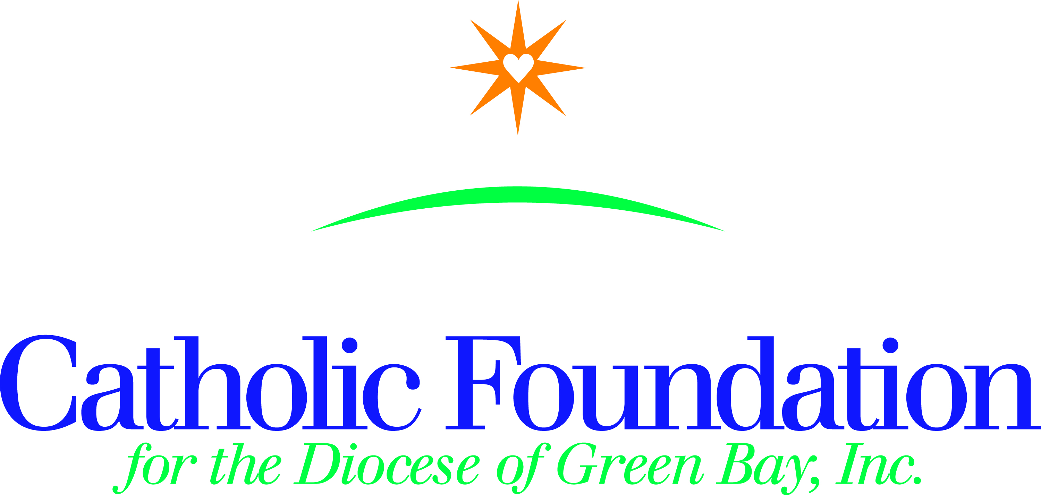

World’s Poor Collection-March 22, 2020 I ask you to please take the following simple steps to promote the World’s Poor collection in your parish;
- Announce the World’s Poor collection in your parish so your parishioners know what it is, when to expect it, and why they should support it.
- Use the bulletin announcements, intercessions and distribute collection envelopes to your parishioners.
- Pray those living in poverty will be comforted, lifted up, and will receive a lasting opportunity to preserve their human dignity through meaningful work.
Bulletin suggestions

Two weeks before collection-March 8, 2020

On the Fourth Sunday of Lent (March 22), we will sponsor a special collection for the World’s Poor. This collection combines an appeal for four Catholic agencies who serve the poor all over the world. This collection includes Catholic Relief Services, the Catholic Campaign for Human Development, Peter’s Pence, and the Pastoral Solidarity Fund for the Church in Africa. In this collection you have a choice to contribute to any one or all four funds, by designating an amount for each on your envelope.

One week before collection-March 15, 2020

The World’s Poor collection provides each of us with an opportunity to change lives for over 1.3 billion people living in poverty in this country and abroad. The four agencies represented in this collection are official church agencies that work to help the poor and displaced. You have a choice to contribute to any one or all.
Catholic Relief Services supports six Catholic agencies as they provide food to the hungry, support to displaced refugees, and advocate for peace and justice. 25% of this collection remains in our Diocese to fight local poverty. Please answer your call to help Jesus in disguise.
The Campaign for Human Development supports programs to empower people to address the obstacles they face as they work to the cycle of poverty. Your support of this collection, gives people a hand up not a hand out. Causes of poverty are addressed to provide a sustainable future for those who struggle across the country. 25% of this collection remains in our Diocese to support local anti-poverty efforts.
Peter’s Pence supports the charitable works of Pope Francis by reaching out to those suffering around the world. Their initiatives provide the Holy Father with the financial means to respond to those who are suffering as a result of war, oppression, natural disaster, and disease.
Pastoral Solidarity Fund for the Church in Africa helps people across Africa grow close to Jesus Christ and the Church. This fund supports pastoral projects to strengthen communities, their faith and foster lasting peace and reconciliation in a continent often marked by division and tension.

Prayerfully consider contributing to this collection to assist those living in poverty, both locally and globally.

On Collection Sunday-World’s Poor Collection – March 22
This weekend in the World’s Poor collection you have a choice to contribute to any one or all of the four organizations. Please designate your wishes for each on your envelope. Your gift will give hope, opportunity and dignity to the poor and marginalized. Please give generously and continue to keep them in prayer.

Intercession suggestions:
English  R/. Lord, hear our prayer  For our Holy Father, Pope Francis, our bishop, N., and all church leaders, that they will continue to proclaim Christ’s love and compassion for the poor as they educate the Church about the need to work for justice in our world, we pray to the Lord.  R/.  For all the suffering people in the world that God will send them ministers of his mercy, and for our parish community, that we may follow Christ’s example of love and solidarity with the poor, we pray to the Lord. R/.  For all of us who have been blessed with an abundance of good things, may we be faithful stewards of God’s charity to our brothers and sisters in need, we pray to the Lord. R/.  For the 46 million people in our country who experience the pain and suffering of poverty every day, may we join with them to share their burden and work to create more just communities, we pray to the Lord. R/. | Spanish  R/. Señor, escúcha nuestra oracion.  Por nuestro Santo Padre, Francisco, nuestro obispo, N., y por todos los líderes de la Iglesia, para que puedan continuar proclamando el amor y la compasión de Cristo por los pobres a la vez que ellos educan a la Iglesia sobre la necesidad de trabajar por la justicia en nuestro mundo,  oremos al Señor. R/.  Por todas las personas que sufren en el mundo, para que Dios les envie unos ministros de su misericordia, y por nuestra comunidad parroquial, para que sigamos el ejemplo de Cristo de amor y de solidaridad con el pobre, oremos al Señor. R/.  Por todos nosotros, que hemos sido bendecidos con abundantes cosas buenas, para que podamos ser unos fieles testigos de la caridad para nuestras hermanas y hermanos necesitados, oremos al Señor. R/.  Por los 46 millones de personas en nuestro país que experimentan el dolor y el sufrimiento de la pobreza todos los días, que podamos unirnos a ellos y compartir su carga y, trabajar para crear comunidades más justas, oremos al Señor. R/

Please mail your parish check and standard remittance form to the Catholic Foundation, PO Box 23001, Green Bay, WI 54305-3001. Resources are also located on our website https://www.catholicfoundationgb.org/resources-world-mission-services/
I am here to serve you. Please contact me with any questions at cstaubin@gbdioc.org Thank you for your assistance. Peace and joy!

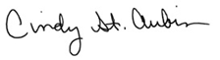
Cindy St. Aubin
World Mission Director

“Whatever you did for one of these least brothers of mine, you did for me” (Matthew 25:40)

