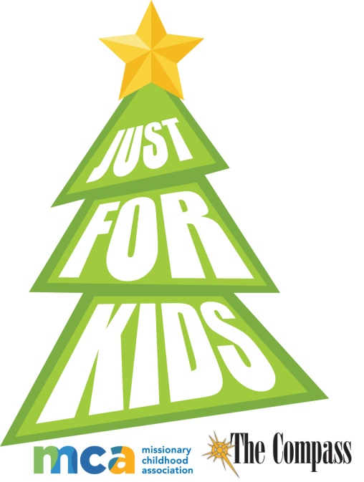
Congratulations to our third Diocesan National Artwork contest winner: Teresa Iannitello-St. Francis Assisi Home School. What a great accomplishment!
Please honor our Savior’s coming and share your talents as Teresa did and enter our contest this year.
The COMPASS Annual “Just for Kids”
Christmas Essay/Artwork Contest

In partnership with World Mission Services, The Compass presents its annual Christmas essay/art contest this year.
The top three artwork winners from each age group, K-8, will be chosen by a diocesan panel. This winning artwork will also be sent to the Missionary Childhood Association National Christmas Artwork Contest. Twenty-four national winners will be selected by MCA and this winning art will appear as e-greeting Christmas cards at www.missio.org/resources and will have their art displayed at the Basilica of the National Shrine of the Immaculate Conception in Washington D.C., during the 2020 Advent and Christmas seasons. Additionally, two grand prize winners’ art will also be featured on the official Christmas cards for the National Director of the Pontifical Mission Society in the United States.

Entry deadline: December 2, 2019. Send entries to: “Just for Kids” Attn. Patricia Kasten, c/o The Compass, P O Box 23825, Green Bay WI 54305-3825. Local Just for Kids winners will be announced in The Compass’ Christmas issue on Dec. 20, 2019.

Students must illustrate the 2019 theme: “The Star of Bethlehem.” This entry form must accompany all Just For Kids artwork. • The illustration must be depicted HORIZONTALLY.

Questions? Please contact Cindy St. Aubin, World Mission Director | 920-272-8192 | wmissions@gbdioc.org

Please complete this form and tape to the back of your art work

STUDENT NAME

PLEASE CIRCLE: | Boy | Girl | Grade
PLEASE CIRCLE: | Catholic School | Parish RE/CCD | Home School

NAME OF SCHOOL OR RE/CCD

PRINCIPAL/CCD DIRECTOR

SCHOOL OR PARISH ADDRESS

SCHOOL OR PARISH PHONE #

DIOCESE

STUDENT’S HOME ADDRESS AS OF SEPTEMBER 2019

PARENT / GUARDIAN

STUDENT’S HOME TELEPHONE NUMBER AS OF SEPTEMBER 2019

PARENT/GUARDIAN E-MAIL ADDRESS
GUIDELINES
- The contest is open to young people in grades K-8 All entries must be postmarked and / or received no later than December 2, 2019
- Each entry (drawing) MUST have this completed entry form taped to the back of the drawing.
- DO NOT GLUE OR STAPLE ENTRY FORM TO ARTWORK. DON’T FOLD ARTWORK!
- It is not possible for entries to be returned.
ARTWORK SPECIFICATIONS
- Artwork must be on an 8.5” x 11” sheet of WHITE paper — no construction or lined paper. White card stock is okay.
- The illustration must be depicted HORIZONTALLY only.
- Students must illustrate the 2019 theme-“The Star of Bethlehem.”
- Acceptable media includes crayons, pastels, markers, tempera or watercolor paints. NO LEAD or COLORED PENCILS.
- Artwork must be the child’s own. Tracings and direct copies of other art cannot be considered.
HELPFUL HINTS
- Use a lot of eye-catching color. Bolder colors reproduce best. Lightly colored artwork will not be seen when reduced. Be careful to erase or cover pencil outlines.
- No text or lettering on the drawing.
- Fill up most of the page, do not to let the parts of the drawing get too close to the edges of the paper.
- Make sure facial features on people and animals are bold (e.g. nose, eyes, lips, etc.) so they will reproduce well.
ESSAY GUIDELINES (Not to exceed 60 words.) Entries should reflect the following question: “What did the Star of Bethlehem look like? Did it make any sound? What was it made of ?”

