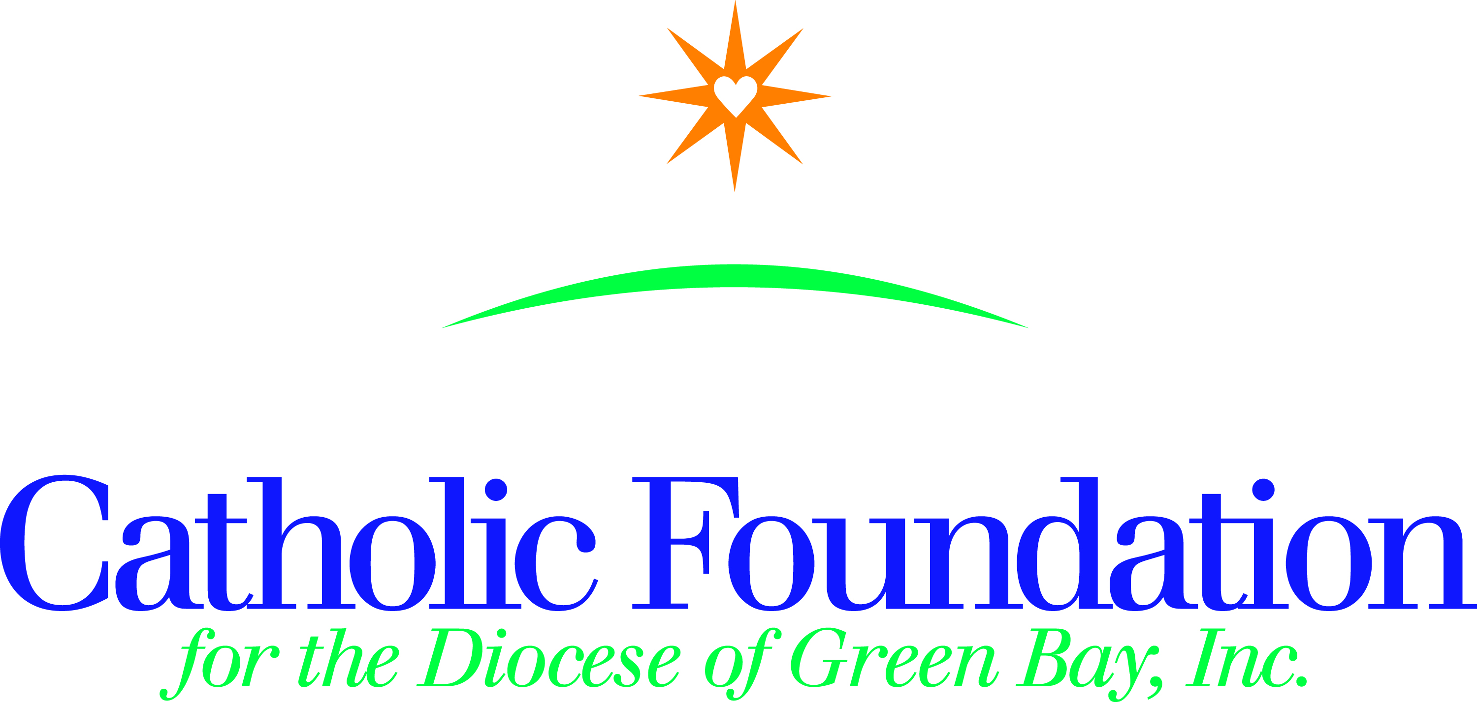

Dear Pastors, Pastoral Leaders, Parish Administrators,

This Lent, we are called forth from the desert to encounter resurrection. Bolstered by faith, Jesus showed courage when confronted by fear. He did not waver in reaching out to those most in need. We are called to do the same, trust that our lives can be ones of fearless encounter; pointing to the hope of the Resurrection. Lent gives us the opportunity to encounter Christ in the desert.

Each day during Lent, we have the opportunity to be inspired by the stories of communities from around the world, to set aside a little of ourselves to make room for a stranger. It is our Gospel call to stand with courage, bringing hope of the Resurrection to a world often beset by hopelessness.

We can encounter the needs of the world through prayer, a commitment to fast, and a readiness to give alms. To serve as a guide for reflection, I invite you to check out both CRS Rice Bowl resources and the World Mission Services Project booklet this Lent. Please share these resources with your families, teachers and students.

CRS Rice Bowl
CRS Rice Bowl is Catholic Relief Services Lenten program for families and faith communities in the United States who want to put their faith into action.

Journey through the 40 days of Lent with a collection of free resources such as; daily reflections; prayer intentions; posters; simple meatless recipes; Lenten calendars; stations of the cross; digital retreats; weekly bulletin or pulpit announcements.

These materials are available in both English and Spanish and are free of charge. CRS rice bowls and resources can be ordered online at www.crsricebowl.org/order and at www.crsricebowl.org

World Mission Services Projects Booklet 2019-2021
The Projects booklet consists of 22 short term mission projects. 100 % of financial contributions to these projects go directly to the project. Support a mission project and experience the needs of the global Church. You can be the hands of Jesus through these projects. Perhaps you’ll assist with home repairs in the Dominican Republic, or assist with a soap making program in Haiti, or bring clean water to children in India or Uganda or have a Noah’s ark project and purchase piglets, chicks or cows for a school in Uganda,. Your support to the www.catholicfoundationgb.org/projects booklet gives the gift of hope.

To enrich your Lenten journey & make a difference in the lives of others, please consider using some of these free resources. Please contact me if you have questions, or are in need of more details. I appreciate your assistance.

Peace,
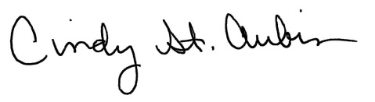
Cindy St. Aubin
World Mission Director
cstaubin@gbdioc.org

