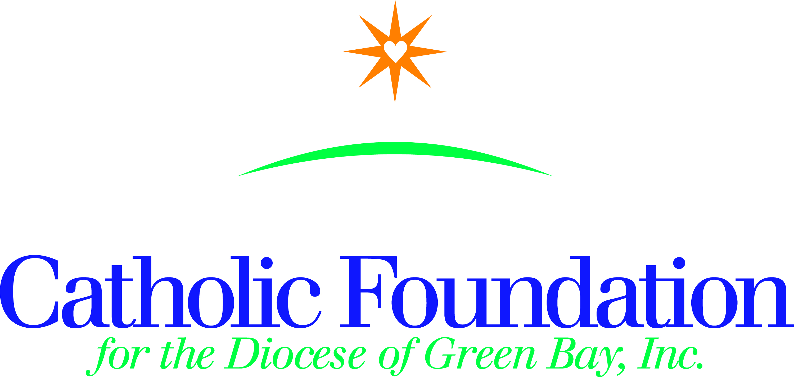

October 24, 2018

Dear Pastors, Parish Administrators and Pastoral leaders,

Our prayers go out to all those who have experienced the devastation of Hurricane Florence and Hurricane Michael. While emergency outreach was immediate, we know the road to recovery and the rebuilding of communities will be long and additional support will be needed.

At the direction of the USCCB, Bishop Ricken is asking all parishes to conduct a second collection for **Disasters 2018** as soon as possible, prior to Thanksgiving. The funds collected in this special appeal for 2018 Disasters will be used to support the efforts of Catholic Charities USA. . . and/or Catholic Relief Services. . . , the official relief agencies of the U.S. Catholic Church as they and their local agencies respond to immediate emergency needs and the United States Conference of Catholic Bishops for pastoral and reconstruction needs of the Church.

We will assist our brothers and sisters impacted by this devastation to support humanitarian aid in the form of water, food, shelter, and medical care, assist with long term efforts to restore communities, and the reconstruction needs of the church.

Funds collected at the parish can be sent to Finance on the standard remittance form (designate for 2018 Disaster relief). Parishioners should make their checks payable to your parish and memo for 2018 Disaster relief. Credit Card donations can be made by calling the Catholic Foundation at 1-920-272-8197.

The need is great to provide assistance and pastoral outreach to those in need and to the church itself. I understand the coordination and work to put this together on such short notice. I thank you for your service to assist those in need. For your convenience a bulletin announcement and the letter from the USCCB president are included below.

Blessings to you and those you serve.

Cindy St. Aubin



World Mission Director

[cstaubin@gbdioc.org](mailto:cstaubin@gbdioc.org)

920-272-8192

**Bulletin Announcement**

**USCCB President Cardinal Daniel DiNardo calls for emergency collection to support 2018 Disaster relief collection.**

Our parishes are encouraged to have an emergency second collection for 2018 Disasters. This collection will aid our brothers and sisters in the southern US, those impacted by the catastrophic damage of Hurricane Florence, Hurricane Michael and other disasters we may encounter in 2018. Our prayers and financial support are needed to help support humanitarian aid, restore communities and the reconstruction needs of the church. Thank you for your generosity to help our brothers and sisters in need. You are truly Missionary Disciples!



***Office of the President***

3211 FOURTH STREET NE WASHINGTON DC 20017-1194  202-541-3100  FAX 202-541-3166

Daniel Cardinal DiNardo

Archbishop of Galveston-Houston

*President*

September 24, 2018

Your Eminence/Excellency:

The traditional storm season has only just begun and already we have witnessed the devastating impact of Hurricane Florence in the Carolinas. Five days after land-fall, torrential rain was still falling, and catastrophic flooding is predicted. Already, thousands of homes, businesses, and churches have been severely damaged or destroyed.

We offer our prayers to families who have lost loved ones or are among those injured. As is often the case, the poor are the hardest hit by these conditions, but many will have immense unmet needs. Staff of our Office for National Collections has been in touch with several bishops to learn about their situations and to offer our prayers and our desire to be of assistance in this time of need.

Given the patterns of recent years, it is reasonable to expect much more unpredictable weather and an increasing number of natural disasters. As we often do in these situations, I suggest we take up a special collection for the humanitarian, long-term recovery, and Church needs arising from these storms. In anticipation of more disasters awaiting us this year, I ask that we make a special appeal for the ongoing disasters of 2018 and that we each take up the collection as soon as possible so that those most in need can receive assistance quickly. I recommend the special collection be taken up on the weekend of September 29-30 or October 6-7 if at all possible.

The funds collected in this special appeal for ***2018 Disasters*** will be used to support the efforts of Catholic Charities USA and/or Catholic Relief Services, the official relief agencies of the U.S. Catholic Church, as they and their local agencies respond to immediate emergency needs for such necessities as water, food, shelter, and medical care and aid in long-term rebuilding and recovery efforts, and the United States Conference of Catholic Bishops for pastoral and reconstruction needs of the Church. Funds will be used in response to Hurricane Florence and any other natural disasters that occur this year.

Your finance staff will be provided with information on this special collection and directions for remitting funds. Additional information on the U.S. Catholic community’s response to this latest emergency and how U.S. Catholics can help can be found at *www.catholiccharities.org* and *www.usccb.org.*

Fraternally yours in our Lord,

Daniel Cardinal DiNardo

Archbishop of Galveston-Houston

President, United States Conference of Catholic Bishops