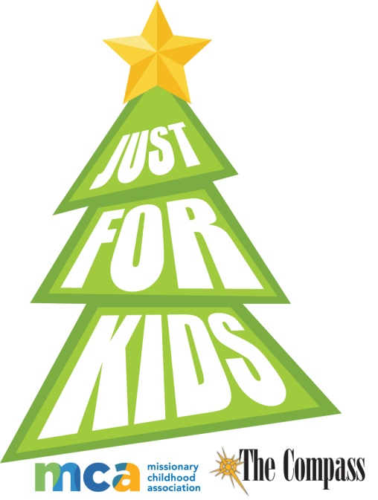
The COMPASS Annual “Just for Kids”
Christmas Essay/Artwork Contest

Congratulations to our second Diocesan National Artwork contest winner: Emily Peters-St. Thomas Aquinas Acadamy-Marinette
What a great accomplishment!
Please honor our Savior’s coming and share your talents as Emily did and enter this year.

In partnership with World Mission Services, The Compass presents its annual Christmas essay/art contest this year.
The top three artwork winners from each age group, K-8, will be chosen by a diocesan panel. This winning artwork will also be sent to the Missionary Childhood Association National Christmas Artwork Contest. Twenty-four national winners will be selected by MCA and this winning art will appear as e-greeting Christmas cards at www.missio.org/resources and will have their art displayed at the Basilica of the National Shrine of the Immaculate Conception in Washington D.C., during the 2019 Advent and Christmas seasons. Additionally, two grand prize winners’ art will also be featured on the official Christmas cards for the National Director of the Pontifical Mission Society in the United States.

Entry deadline: December 3, 2018. Send entries to: “Just for Kids” Attn. Patricia Kasten, c/o The Compass, P O Box 23825, Green Bay WI 54305-3825. Local Just for Kids winners will be announced in The Compass’ Christmas issue on Dec. 21, 2018.

This entry form must accompany all Just For Kids artwork.

Questions? Please contact Cindy St. Aubin, World Mission Director | 920-272-8192 | wmissions@gbdioc.org

Please complete this form and tape to the back of your art work

STUDENT NAME

PLEASE CIRCLE: | Boy | Girl | Grade
PLEASE CIRCLE: | Catholic School | Parish RE/CCD | Home School

NAME OF SCHOOL OR RE/CCD

PRINCIPAL/CCD DIRECTOR

SCHOOL OR PARISH ADDRESS

SCHOOL OR PARISH PHONE #

DIOCESE

STUDENT’S HOME ADDRESS AS OF SEPTEMBER 2018

PARENT / GUARDIAN

STUDENT’S HOME TELEPHONE NUMBER AS OF SEPTEMBER 2018

PARENT/GUARDIAN E-MAIL ADDRESS
GUIDELINES
- The contest is open to young people in grades K-8 All entries must be postmarked and / or received no later than December 3, 2018
- Each entry (drawing) MUST have this completed entry form taped to the back of the drawing.
- DO NOT GLUE OR STAPLE ENTRY FORM TO ARTWORK. DON’T FOLD ARTWORK!
- It is not possible for entries to be returned.
ARTWORK SPECIFICATIONS
- Artwork must be on an 8.5” x 11” sheet of WHITE paper — no construction or lined paper. White card stock is okay.
- The illustration may be depicted HORIZONTALLY or VERTICALLY.
- Students must illustrate the 2018 theme-“The newborn Baby Jesus in the manger.”
- Acceptable media includes crayons, pastels, colored pencils, markers, tempera or watercolor paints. PLEASE — NO LEAD PENCILS.
- Artwork must be the child’s own. Tracings and direct copies of other art cannot be considered.
HELPFUL HINTS
- Use a lot of eye-catching color. Bolder colors reproduce best. Lightly colored artwork will not be seen when reduced. Be careful to erase or cover pencil outlines.
- No text or lettering on the drawing.
- Fill up most of the page, do not to let the parts of the drawing get too close to the edges of the paper.
- Make sure facial features on people and animals are bold (e.g. nose, eyes, lips, etc.) so they will reproduce well.
ESSAY GUILDELINES (Not to exceed 60 words.) Entries should reflect the following question: “Why did Jesus come to earth as a baby and not as a full-grown adult?”

