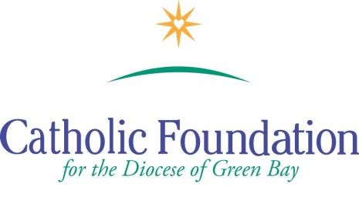
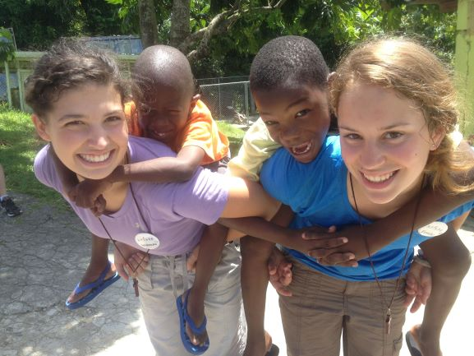
World Mission Sunday Appeal –October 21, 2018 Suggested Bulletin Announcements
Week before the Collection
Next weekend we will celebrate World Mission Sunday, a day we recommit ourselves to our common vocation through Baptism, to be missionary disciples. It is one Sunday for the Whole World. Pope Francis calls all children of God to be “voices for mission.” Places like Uganda where people face food uncertainty and violence…in the Philippines where local clergy face martyrdom…in Oceania where people’s livelihoods are threatened by climate change…and in remote regions of Latin America where people are hearing the Gospel for the first time. We speak up through our prayers and personal sacrifices for our brothers and sisters. Please keep the Missions in your prayers and please be generous.
Weekend of World Mission Sunday
Today is World Mission Sunday, a special moment of encounter with the Pope’s missions throughout the world. I invite all of us to raise our voices this World Mission Sunday by supporting the Priests, religious Sisters and Brothers, and lay catechists who provide loving service to those most in need. Your prayers and generous gifts to the Society for the Propagation of the Faith, Latin America and Eastern Europe will help missionaries share the joy of the Gospel and help the poor by our fervent prayer and generous hearts.

Weekend after World Mission Sunday

Thank you for your generous heart, fervent prayer and gifts to the World Mission Sunday collection. As Pope Francis says “Mission is part of the ‘grammar’ of faith, something essential for those who listen to the voice of the Spirit who whispers ‘Come’ and ‘Go forth.’ Those who follow Christ cannot fail to be missionaries…” You are truly missionary disciples!

