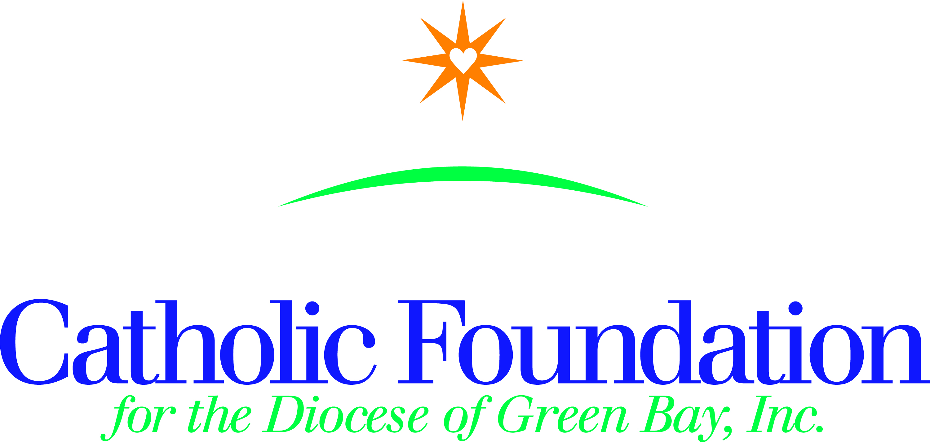

Home Mission Collection-Our Own Needs-May 19-20, 2018 Please take the following simple steps to promote the Home Mission collection in your parish:
1. Announce the Home Mission collection in your parish so your parishioners know what it is, when to expect it, and why they should support it.
2. Use the bulletin announcements and distribute collection envelopes to your parishioners, or take a second collection.
3. Pray those in need of our assistance will be comforted and lifted up, and that they will receive a lasting opportunity to know Jesus Christ.

Bulletin suggestions Home Missions-Our Own Needs Collection – May 20, 2018-Strengthening the Church at Home

The four major beneficiaries represented in this collection along with their purpose and mission are;
The Catholic Communications Campaign connects people with Christ through media programming to promote Gospel values. As people continue to access more information on mobile devices there is an increased need to provide Faith resources on these platforms as well. This campaign supports televised Masses and Catholic newspapers. Fifty percent of the funds collected remain in our diocese.
The Catholic Home Missions Appeal assists over 80 Home Mission dioceses in the United States. They unable to fund the essential pastoral work needed in their communities. Your support helps ease the struggle of these dioceses and ensures the Gospel is spread across the United States. Basic services include Mass, the sacraments, and religious education.
The Black and Native American Missions – exist to build Christion communities among the Native American, African American and Alaska Native people in the U.S. Every penny collected is given out in Diocesan grants to support pastoral ministry. In our Diocese, we annually receive a grant from this collection for outreach for our parishes in Neopit & Keshena in their outreach and service to the Menominee Indian Tribe.
The Catholic University of America established by the Vatican and U.S. Bishops, located in Washington D.C. is the National University of the Catholic Church. It provides an education guided by Catholic tradition to nearly 7,000 students every year. Every donated dollar directly supports financial aid for students. One third of our U.S. Bishops are alumni, along with 12, 400 priests. Thank you for your generosity.
Please mail your parish check and standard remittance form to the Catholic Foundation, PO Box 23001, Green Bay, WI 54305-3001. I am happy to answer any questions you may have. I am here to serve you. Thank you for your assistance.

Peace and joy!
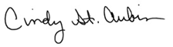
Cindy St. Aubin
World Mission Director

“Loves makes itself if felt in every action that seeks to build a better world” Pope Francis

