BA18 Facebook Guide for Parishes

Instructions: This document is a sample plan for Bishop’s Appeal Facebook posts. You may follow this plan or select the posts you want to put on your parish Facebook page.

- Download the Facebook images from the Catholic Foundation website. Create an image post in Facebook and select the image you want to use.

- Copy the text inside the box and paste it into your Facebook Post. Include the give link www.catholicfoundationgb.org/gvie so parishioners can click and go directly to the online giving page.

Friday, February 2

Bishop’s Appeal 2018 begins this weekend! To learn how you can help, read Bishop Ricken’s message on Embracing a Life of Discipleship in Bishop’s Corner Column in The Compass. www.catholicfoundationgb.org/give

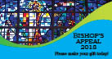

Sunday, February 4

Bishop’s Appeal 2018 officially kicks-off today! Watch for stories on how the Bishop’s Appeal impacts people’s lives in northeastern Wisconsin. To learn more about how you can help, visit our website at www.catholicfoundationgb.org/give
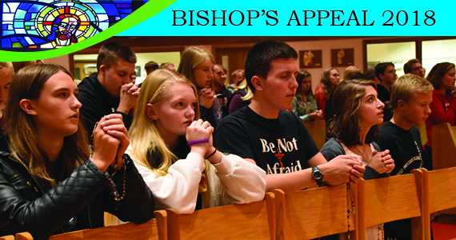

Wednesday, February 7

Bishop’s Appeal 2018 has begun. Over the next few weeks we will be sharing stories about Embracing a Life of Discipleship and how people are helped by the Bishop’s Appeal. Please give generously to the Bishop’s Appeal.
www.catholicfoundationgb.org/give

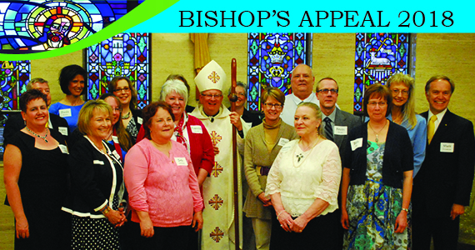

Friday, February 9

Have you received your letter from Bishop Ricken in the mail this week? “Like” this post if you have! Thank you! Please consider making a gift to the 2018 Bishop’s Appeal.
www.catholicfoundationgb.org/give

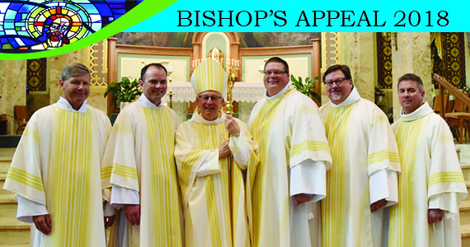

Sunday, February 11

View our video to learn more about how people in our Diocese are Embracing a Life of Discipleship. Gifts to the 2018 Bishop’s Appeal are needed and greatly appreciated!
www.catholicfoundationgb.org/give

Bishop’s Appeal Video

Friday, February 16

Care ministers provide a listening ear, a smiling face and share prayers and Holy Communion with the homebound and sick.

Your gift makes it possible for care ministers to receive the training to share God’s love and friendship! Please give generously to the Bishop’s Appeal.
www.catholicfoundationgb.org/give

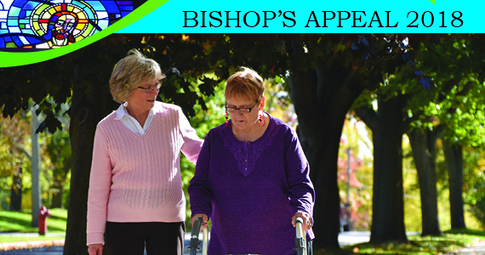

Friday, February 23

Every child deserves a forever home! Support Catholic Charities Adoption Services with a gift to the Bishop’s Appeal.
www.catholicfoundationgb.org/give

Sunday, February 25

The Emmaus Lay Ministry program forms and mentors future church leaders in our parishes such as coordinators of pastoral ministry, liturgy, faith formation, youth ministry and business managers. Help train our future leaders. Give to the Bishop’s Appeal today!
www.catholicfoundationgb.org/give

Wednesday, February 28

A Catholic education is priceless! Catholic educators teach our children to know and love Jesus. Make sure they have the needed tools and training by making a gift to the Bishop’s Appeal today!
www.catholicfoundationgb.org/give

Sunday, March 4

Sr. Laura Zelten and the college students at UW Green Bay’s Catholic Campus Ministry have created a faith-filled community. Sr. Laura is helping to form life-long disciples! Please support our college Campus Ministry programs.
www.catholicfoundationgb.org/give

Wednesday, March 7

Youth Ministry offers inspiring events and retreats like Youth Jam, March for Life, Steubenville and many more! Through these experiences young people learn to know, love and serve God. Support our youth by giving to the Bishop’s Appeal!
www.catholicfoundationgb.org/give

Sunday, March 11

Camp Tekakwitha provides children with the opportunity to connect with Jesus while exploring His playground in the north woods. Please give generously to the Bishop’s Appeal.
www.catholicfoundationgb.org/give

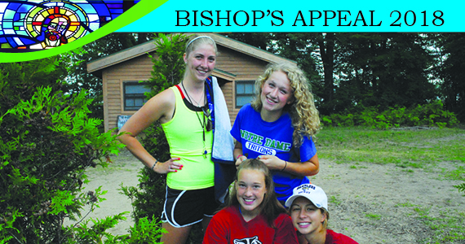

Wednesday, March 14
In Marriage Preparation classes couples are given spiritual resources, information on Natural Family Planning and communication tools. The Bishop’s Appeal proudly supports this important ministry, helping couples make Christ the very center of their marriage and family.
www.catholicfoundationgb.org/give

Sunday, March 18
Deacons Embrace a Life of Discipleship. Not only do they assist at Mass, they share the Gospel with people in prisons, hospitals, shelters, youth programs and those who are homebound. They are the hands and face of Christ. Support our Diaconate program by giving to the Bishop’s Appeal.
www.catholicfoundationgb.org/give

