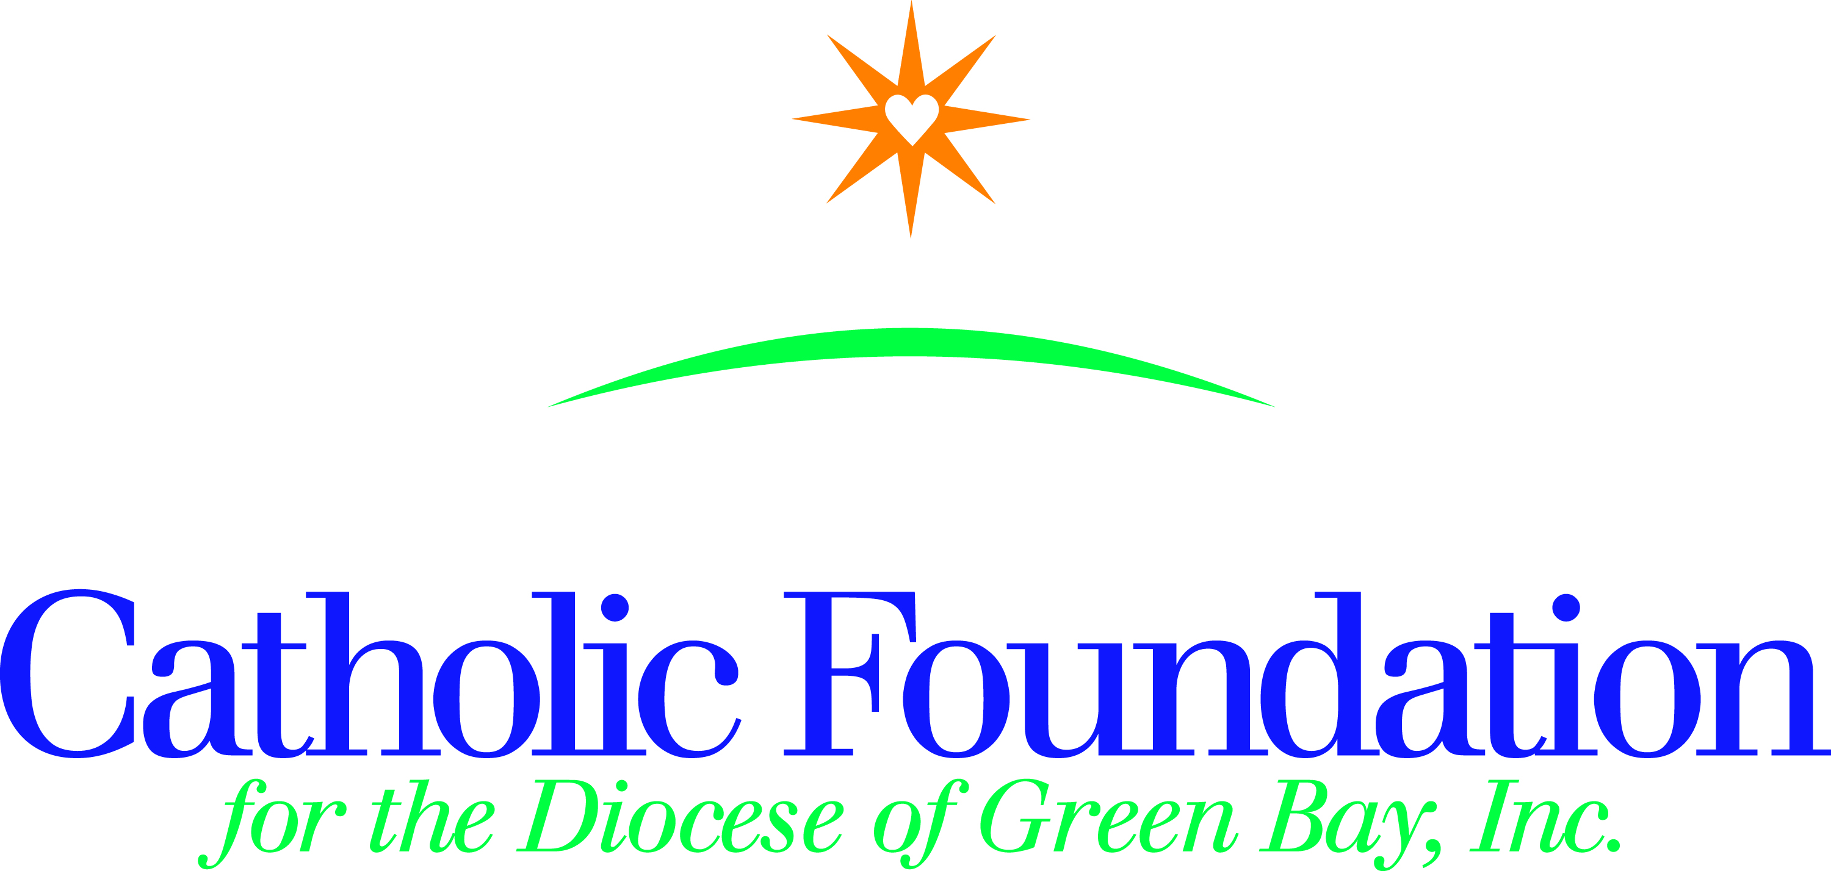
World’s Poor Collection-March 10-11, 2018 Please take the following simple steps to promote the World’s Poor collection in your parish:
1. Announce the World’s Poor collection in your parish so your parishioners know what it is, when to expect it, and why they should support it.
2. Use the bulletin announcements, intercessions and distribute collection envelopes to your parishioners.
3. Pray that those living in poverty will be comforted and lifted up, and that they will receive a lasting opportunity to preserve their human dignity through meaningful work.
Bulletin suggestions

Two weeks before collection-February 24-25

On the Fourth Sunday of Lent (March 10-11), we will sponsor a special collection for the World’s Poor. This collection combines an appeal for four agencies that serve the poor and those living on the edge of society all over the world. This collection includes the Catholic Campaign for Human Development, Catholic Relief Services, Peter’s Pence, and the Pastoral Solidarity Fund for the Church in Africa. In this collection you have a choice to contribute to any one or all four funds, by designating an amount for each.

One week before collection-March 3-4

The World’s Poor collection provides each of us with an opportunity to change lives for over 1.4 billion people living in poverty in this country and abroad. The four agencies represented in this collection are official church agencies that work to help the poor and displaced. You will have a choice to contribute to any one or all.
The Campaign for Human Development supports programs to empower people to identify and address the obstacles they face as they work to lift themselves out of poverty. Your support of this collection, gives people a hand up not a hand out. They address the causes of poverty and provide a sustainable future for those who struggle across the country. Also 25% of this collection remains in our diocese to support local anti-poverty efforts.
Catholic Relief Services supports six Catholic agencies as they provide food to the hungry, support to displaced refugees, and advocate for peace and justice. They serve some of the most vulnerable populations at home and abroad. Please answer your call to help Jesus in disguise.
Peter’s Pence Be a witness of Charity. This collection is an opportunity to share in the merciful outreach of Pope Francis. Please join together with our brothers and sisters in faith around the world to provide a little more mercy into the lives of those who hunger and thirst, strangers and prisoners, the marginalized and the outcast, the victims of oppression and violence.
Pastoral Solidarity Fund for the Church in Africa help people across Africa grow close to Christ and the Church. People are flocking to join the church, dioceses are not equipped to respond to their needs. With your support, the local Church is able to nurture the faith and encourage missionary discipleship.

Please give generously!

On Collection Sunday-World’s Poor Collection – March 10-11
This weekend in the World’s Poor collection you have a choice to contribute to any one or all of the four organizations. Please designate your wishes for each on the envelope. Your gift will help give hope, opportunity and dignity to the poor and marginalized people of the world. Please give generously!

Intercession suggestions:
English  R/. Lord, hear our prayer  For our Holy Father, Pope Francis, our bishop, N., and all church leaders, that they will continue to proclaim Christ’s love and compassion for the poor as they educate the Church about the need to work for justice in our world, let us pray to the Lord.  R/.  For the World’s Poor, for all who work to address poverty in this country, and for our parish community, that we may follow Christ’s  example of love and solidarity with the poor, let us pray to the Lord. R/.  That we, the people of God, will open our hearts and souls to justice so that we will speak and act in ways that will eliminate poverty and injustice in this country and throughout the world, let us pray to the Lord. R/.  For the 46 million people in our country who experience the pain and suffering of poverty every day, may we join with them to share their burden and at the same time work to create more just communities, let us pray to the Lord. R/. | Spanish  R/. Señor, escúchanos.  Por nuestro Santo Padre, Francisco, nuestro obispo, N., y por todos los líderes de la Iglesia, para que puedan continuar proclamando el amor y la compasión de Cristo por los pobres a la vez que ellos educan a la Iglesia sobre la necesidad de trabajar por la justicia en nuestro mundo,  oremos al Señor. R/.  Por los pobres del mundo, por todos los que trabajan tratando de erradicar la pobreza en este país, y por nuestra comunidad parroquial, para que sigamos el ejemplo de Cristo de amor y de solidaridad con el pobre, oremos al Señor. R/.  Que nosotros, el Pueblo de Dios, abramos nuestro corazón y nuestra alma a la justicia para que hablemos y actuemos en maneras que eliminen la pobreza y la injusticia en este país y en todo el mundo, oremos al Señor. R/.  Por los 46 millones de personas en nuestro país que experimentan el dolor y el sufrimiento de la pobreza todos los días, que podamos unirnos a ellos y compartir su carga y, al mismo tiempo, trabajar para crear comunidades más justas, oremos al Señor. R/

Please mail your parish check and standard remittance form to the Catholic Foundation, PO Box 23001, Green Bay, WI 54305-3001. I am happy to answer and questions you may have. I am here to serve you. Thank you for your assistance. Peace and joy!

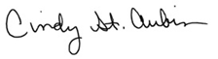
Cindy St. Aubin
World Mission Director

“Let us never forget; in the face of the suffering of so many people worn out by hunger, violence and injustice, we cannot remain spectators”-Pope Francis

