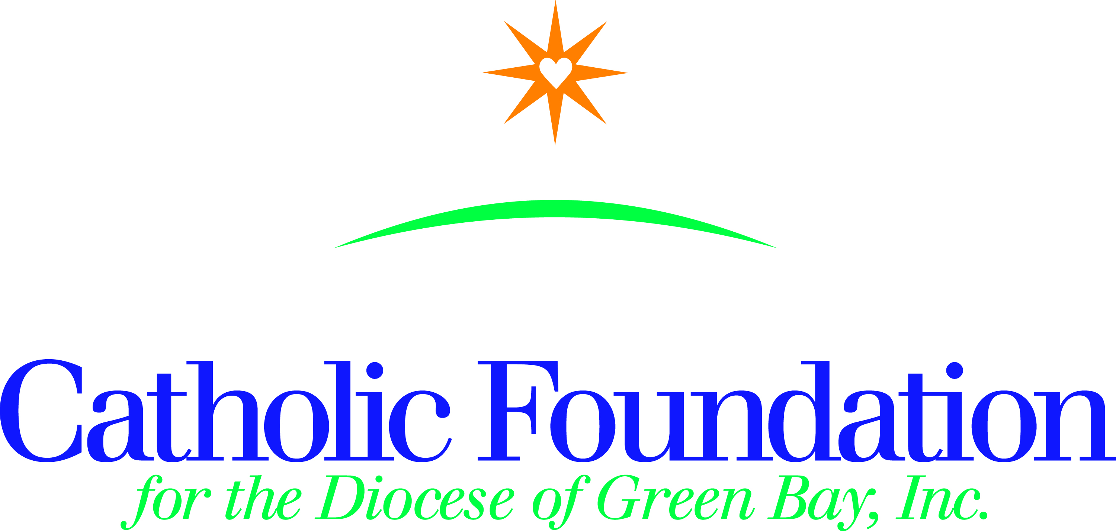

Dear Pastors, Pastoral Leaders, Parish Administrators,

Our faith calls us to be a companion on the journey to those most in need. We hear this call clearly throughout the Gospel and we hear it in Pope Francis invitation to welcome our neighbors-especially the migrants and refugees. As we prepare for Lent, we are invited to reflect on how we—as people of faith—might contribute to this culture of encounter. Please journey alongside the Good Samaritan, to reflect on the question: Who is my neighbor?

CRS Rice Bowl provides resources to bring Lenten spirituality to life for families, parish and school communities, while continuing to connect Catholics in our Diocese with our brothers and sisters in need around the world.

To serve as a guide for your community’s reflection, I invite you to use CRS Rice Bowl resources and the World Mission Services Project booklet this Lent.

CRS Rice Bowl
CRS Rice Bowl is Catholic Relief Services’ Lenten program for families and faith communities in the United Sates who want to put their faith into action. Participants are invited to hear stories about their brothers and sisters in need around the world, and devote their Lenten prayers, fasting and alms to change the lives of those who suffer in poverty.

Journey through the 40 days of Lent with a collection of daily reflections and activities included in the CRS Rice Bowl calendar and on the mobile app.

As always, 75% of your contribution to Rice Bowl supports programs to help families and communities overcome the challenges of hunger and poverty. 25% remains in our Diocese to support local hunger and poverty efforts.

These materials are available in both English and Spanish and are free of charge. CRS resources can be found at;

https://www.crsricebowl.org/about/ricebowl-faq

https://www.crsricebowl.org/about/mediakit/web-ready-content

https://www.crsricebowl.org/digital-retreat

https://www.crsricebowl.org/about/mediakit/media-releases

https://www.crsricebowl.org/schools

https://www.crsricebowl.org/recipe

https://www.crsricebowl.org/families

World Mission Services Projects Booklet
The Projects booklet consists of 24 short term mission projects. Support a mission project and experience the needs of the global Church. You can be the hands of Christ by assisting these projects. Perhaps you’ll have a Noah’s ark project and purchase piglets, chicks or cows for a school in Uganda, build a latrine for the Dominican Republic, or a community center in Haiti, or help feed children in Bolivia or the Philippines. Your support to the www.catholicfoundationgb.org/projects booklet gives the gift of hope for a better future.

To enrich your journey & make a difference in the lives of others, please consider placing some of these resources in your bulletin, prior to Ash Wednesday, February 14, 2018.

However you prepare for Easter during your 40-day Lenten journey, may you see the light of hope and be the light of hope to others.

Peace,
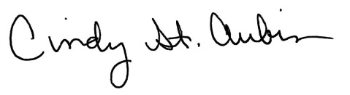
Cindy St. Aubin
World Mission Director
cstaubin@gbdioc.org

