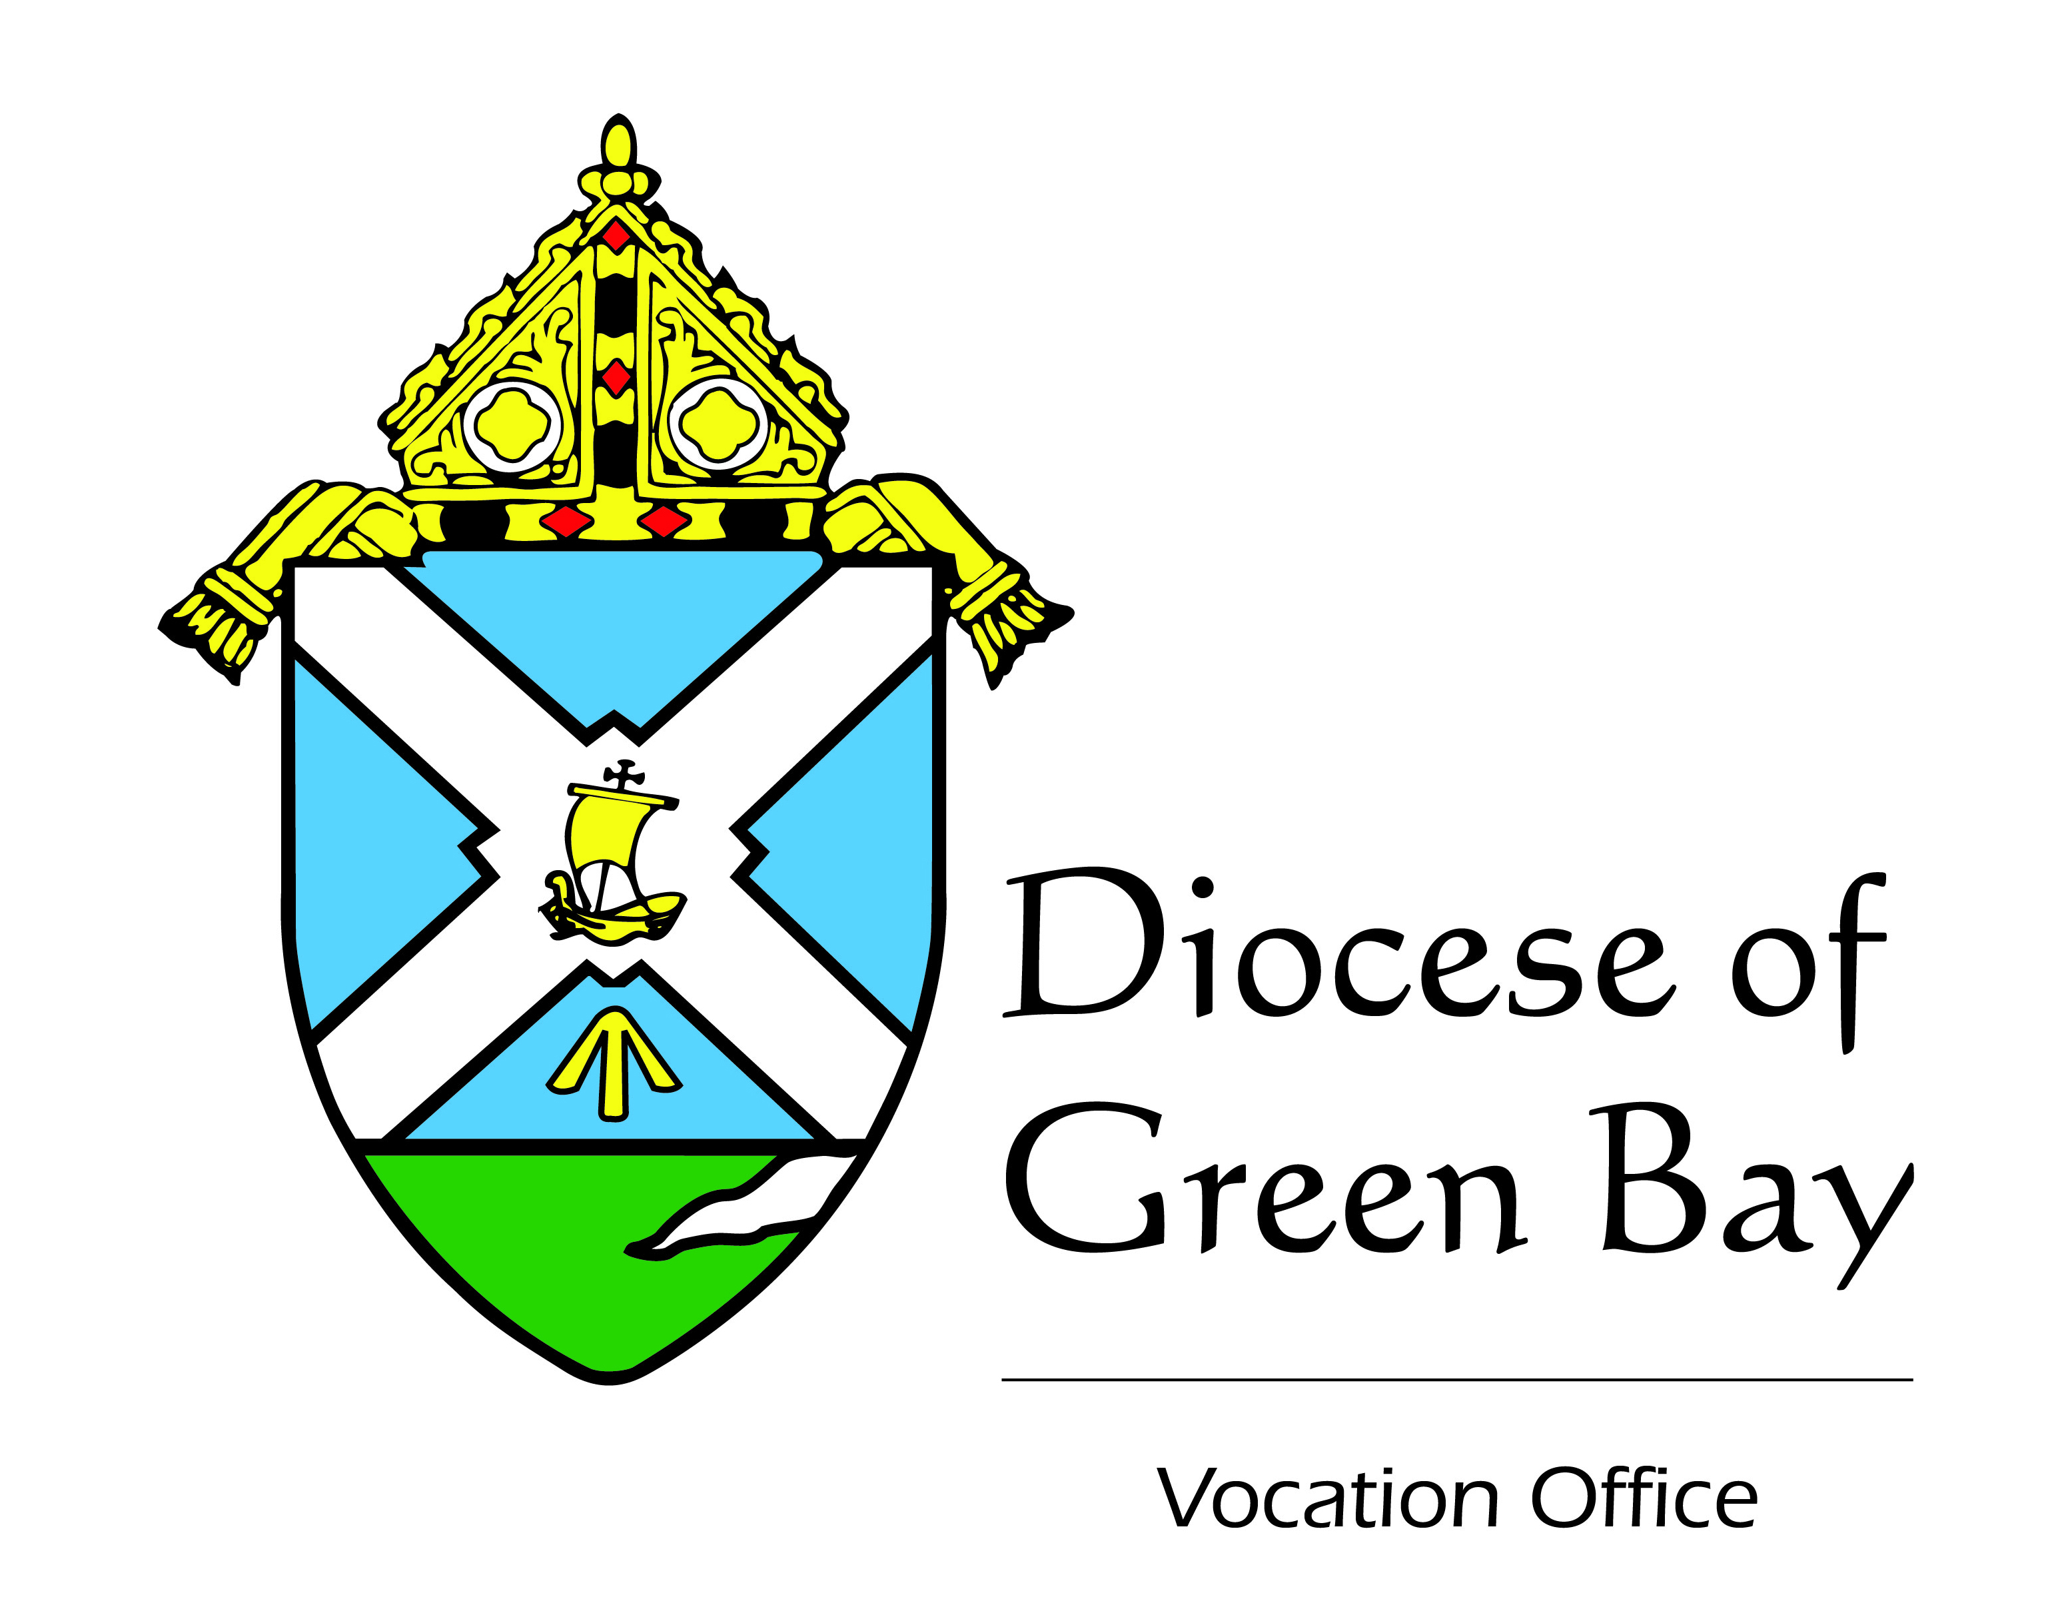
Bulletin Announcements for Seminarian Collection 2017

Two Weekends Prior to the Collection Kickoff:
Hope for the Future, Help them Today: As friends and followers of Jesus, we need to provide for the needs of our future spiritual fathers. In about two weeks, we can do just that by supporting the annual Seminarian Collection: Hope for the Future, Help them Today. Watch your mailboxes for more details. The money donated will be used to benefit the education and formation of our own seminarians and to support the growth of priestly vocations. Please be generous!
One Weekend Prior to the Kickoff:
Our Seminarians Need Your Help: Our diocese has witnessed incredible growth in all vocations including the priesthood. Let’s keep that growth going and support our future spiritual fathers! Please be generous with our Annual Seminarian Collection: Hope for the Future, Help them Today. An important letter will arrive in your mailbox this week asking for your help. Next weekend is the kick off of this annual collection. Your donation provides tuition, room and board, insurance, a small stipend for our seminarians and will support the Vocation Office’s efforts to call forth more candidates. The total annual cost for our 25 seminarians is around $1,000,000. As friends and followers of Jesus, we support each other. In order to make your gift today, visit www.catholicfoundationgb.org/give.
[On (date) , (seminarian) , will speak at our Masses so we can hear about his calling and how we can help.]
Kickoff Weekend of the Collection:
Seminarian Collection Kickoff: A spiritual family needs spiritual fathers. That is why the Annual Seminarian Collection: Hope for the Future, Help them Today is so important. By now you most likely received a letter from Bishop Ricken requesting your help in supporting our local seminarians. Please return your generous contribution to this collection, using the pledge card and return envelope you received in the mail. A gift of $25, $100, $250, $500 or more will help our seminarians move forward in their work of becoming missionary disciples. Every gift makes a difference. Our seminarians are our Hope for the Future, Let us Help them Today! As a Diocese, we anticipate costs of $1,000,000 this year for tuition, room and board, health insurance, support of the Office of Vocations and the work of Fr. Daniel Schuster and Fr. Quinn Mann. Friends and followers of Jesus support one another! To make your gift today, visit www.catholicfoundationgb.org/give.
[On (date) , (seminarian) , will speak at our Masses so we can hear about his calling and how we can help.]

2nd Weekend in August:
Our annual Seminarian Collection is underway. By now, you have received a letter from Bishop Ricken inviting you to take part in the vocation mission. Please return the pledge card through the mail, or donate online at www.catholicfoundationgb.org/give. Whatever you are able to give is greatly appreciated.
[On (date) , (seminarian) , will speak at our Masses so we can hear about his calling and how we can help.]
3nd Weekend in August:
Our annual Seminarian Collection is working. By now you have received a letter from Bishop Ricken asking that you participate in Hope for the Future: Help them Today. Have you made your gift? So far this year our parish(es) have raised $______________. Last year, we raised a total of $____________________. Let us see if we can increase our support of this important part of the mission of the Diocese of Green Bay. Make your gift today by mailing in your pledge card or visit www.catholicfoundationgb.org/give.
4th Weekend in August:
Thank you to those who have participated in the annual Seminarian Collection: Hope for the Future, Help them Today. There is still time to respond to the great need we have to support our local seminarians. Have you made your gift? So far this year our parish(es) have raised $______________. Last year, we raised a total of $____________________. Let us see if we can increase our support of this important part of the mission of the Diocese of Green Bay. Disciples need to support one another. Make your gift today by mailing in your pledge card or visit www.catholicfoundationgb.org/give.

