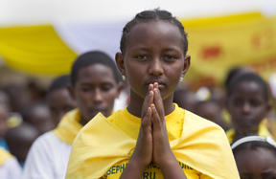
World Mission Sunday
Mercy Changes the World
Prayers of the Faithful-suggestions

As a people of prayer called to live the Gospel and build up the Church in love, we offer prayers for our sisters and brothers throughout the world. We pray to the Lord…
For our Holy Father, Pope Francis, that the Lord might strengthen him in faith and courage as he proclaims the loving mercy of God to all his people. We pray to the Lord…

For civil leaders of nations, that they may govern their people justly and work for lasting peace. We pray to the Lord…

For missionaries who share the mercy of God, and the beating heart of the Gospel, that they may never tire in their service to the poor. We pray to the Lord…

For all those who support the missionary efforts of the Church throughout the world through prayer and sacrifice. We pray to the Lord…

For this Eucharistic assembly, that the Holy Spirit might inspire us to renew our missionary spirit so that through word and deed we might help to make Christ known to people throughout the world. We pray to the Lord…

For the sick of the parish, that in bearing their illnesses in union with Christ, they might offer their suffering so all those who hear God’s Word proclaimed by the witness and work of missionaries might be open to God’s call. We pray to the Lord…

For all those who have died, especially missionaries, that they might enjoy the presence of the Risen Christ in the Kingdom of God. We pray to the Lord…

