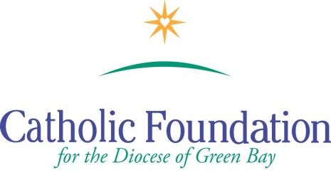

World Mission Sunday Appeal –October 22, 2016
Mercy Changes the World
Suggested Bulletin Announcements

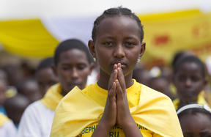

Week before the Collection
Next weekend we will celebrate World Mission Sunday and the mercy of God as we extend His loving heart to our neighbors half a world away. At Mass on Sunday, we are invited to “go out” as missionary disciples, each generously offering our talents, creativity, wisdom and experience to bring the message of God’s tenderness and compassion to the entire human family. Please keep the Missions in your prayers and please be generous.
Weekend of World Mission Sunday
Today is World Mission Sunday. It is a day we recommit ourselves to our common vocation through Baptism, to be missionaries. Your prayers and generous gifts to the Society for the Propagation of the Faith, Latin America and Eastern Europe will help missionaries offer the poor of these areas practical help. The missionaries also share the mercy of God and connect us with people in need around the world.

Weekend after World Mission Sunday

Thank you for your generosity of spirit and heart to the World Mission Sunday collection. We appreciate your missionary commitment to share the joy of the Gospel and help the poor. You are truly missionary disciples. We pray for blessings for you and your families.

