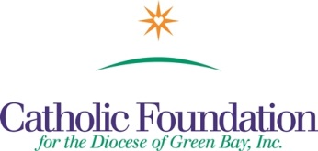

Bulletin Suggestions
Home Missions-Our Own Needs Collection – May 14-15, 2016
Strengthening the Church at Home

Home Missions-Our Own Needs Collection will take place on Pentecost Sunday, May 15, 2016. Please support this important work here in the United States. The four major beneficiaries are:

Catholic Communications Campaign –develops media programming to promote Gospel values. Half of all proceeds raised stay in our Diocese. It provides grants to Catholic organizations to support televised Masses, diocesan newspapers. Nationally, 2015 CCC funds supported live streaming and social media campaigns of Pope Francis U.S. visit.

Catholic Home Missions Appeal –There are over 80 Home Mission dioceses in the United States. They struggle to serve the unique needs of their communities. The Home Missions Appeal helps to ease the struggle of these dioceses and helps them form vibrant faith communities.

Black and Native American Missions – exist to help diocesan communities to build the Church and preach the Gospel of Jesus among the Native American, African American and Alaska Native people of God in the U.S. These funds support pastoral ministry, education, evangelization in dioceses where these communities exist. In our Diocese, we annually receive a grant from this collection to assist parishes in Neopit & Keshena in their outreach and service to People of the First Nation (Menominee Indian Tribe).

Catholic University of America – The Catholic University of America is the national University of the Catholic Church in the United States, located in Washington, D.C. It provides an academically rigorous education guided by the Catholic intellectual tradition to nearly 7,000 students every year. One hundred percent of this collection is used for financial aid. More than 4,000 students directly receive scholarship aid from this Collection, including many from our diocese.

Please Give Generously

Thank you,
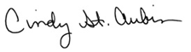
World Mission Coordinator

WE’RE ALL MISSIONARIES - WORLD MISSION SUNDAY, October 24, 2010

