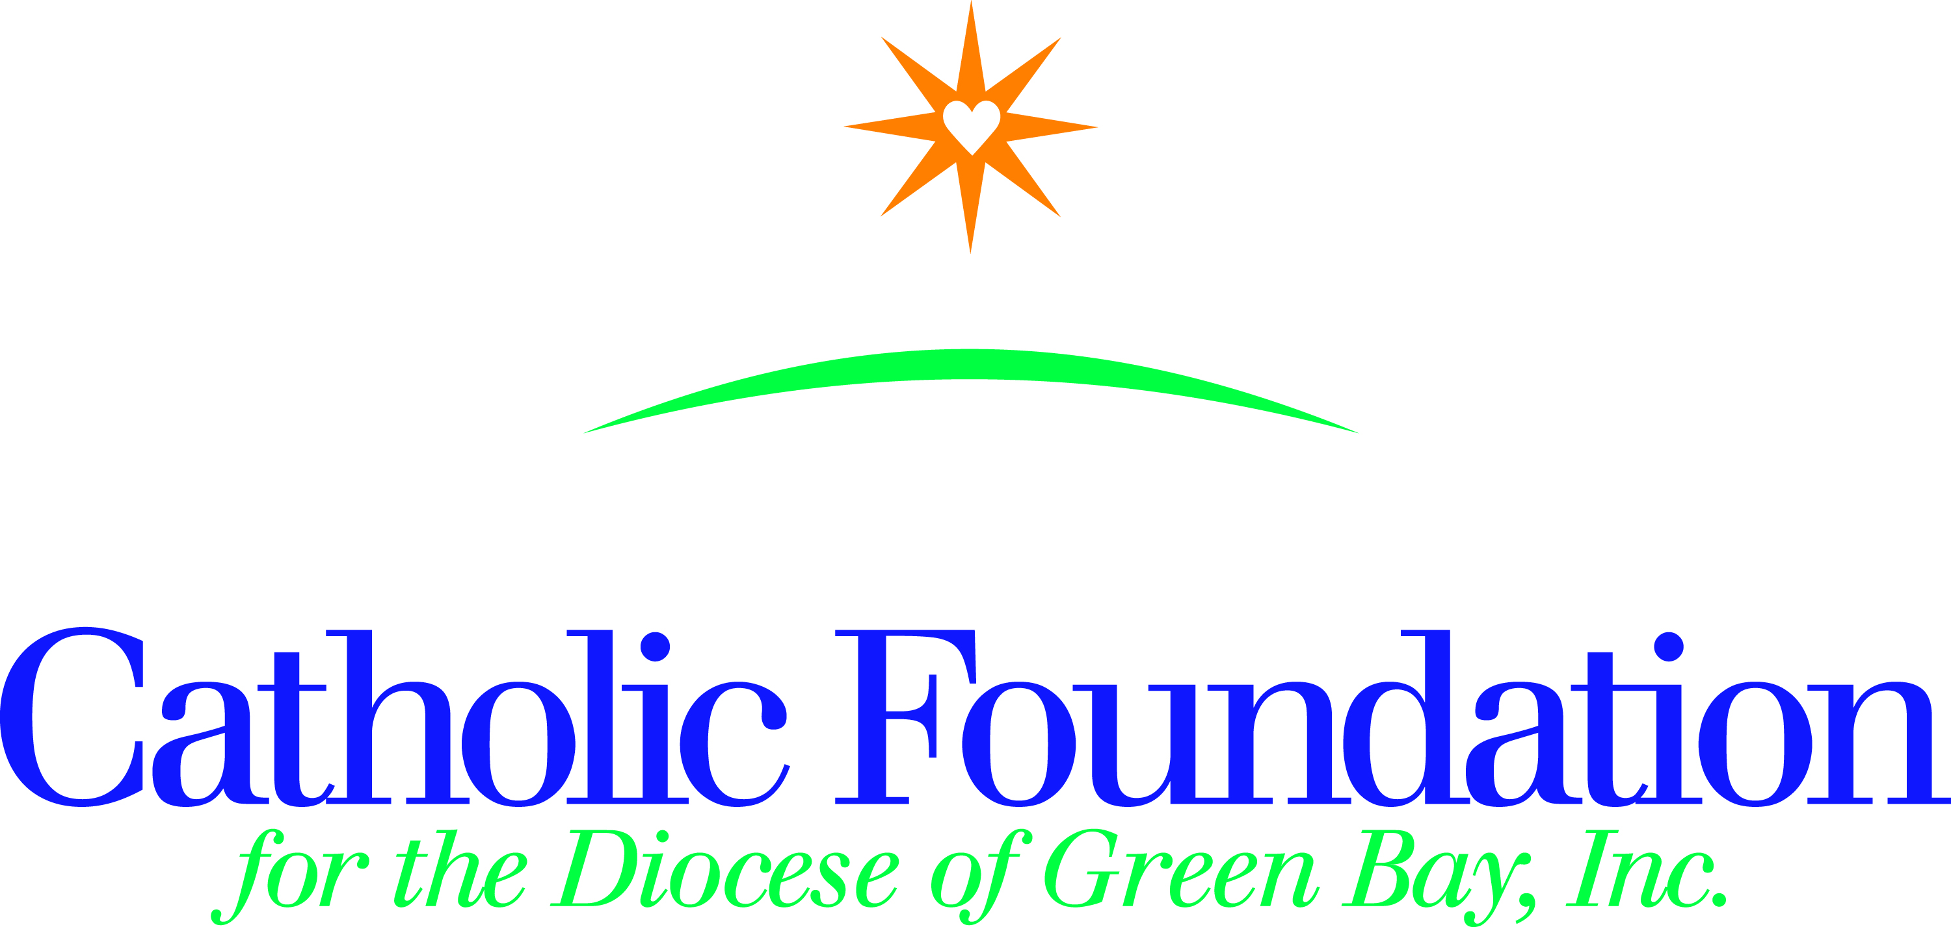

Dear Pastors, Pastoral Leaders, Parish Administrators,

Our faith calls us to build a culture of encounter. We hear this call clearly throughout the Gospel and we see it reflected in Pope Francis’ daily example. As we prepare for Lent, we are invited to reflect on how we—as people of faith—might contribute to this culture of encounter. To serve as a guide for your community’s reflection, I invite you to use CRS Rice Bowl and the World Mission Services Project booklet this Lent.

CRS Rice Bowl provides resources to bring Lenten spirituality to life for families and parish and school communities, while continuing to connect Catholics in our Diocese with our brothers and sisters in need around the world.

These materials are available in both English and Spanish and are free of charge. You may also visit crsricebowl.org or crsplatodearroz.org to find additional resources, including:

- Lenten devotions and prayers
- Reflections for faith-sharing communities and youth ministry groups
- Lesson plans, videos and activity sheets for Catholic school teachers and religious educators
- Ideas for community gatherings and simple Lenten meal events
- A Lenten app that delivers prayers and resources directly to your mobile device

To enrich your journey & make a difference in the lives of others, please consider the following resources for your February 26, 2017 bulletin.

CRS Rice Bowl
CRS Rice Bowl is Catholic Relief Services’ Lenten program for families and faith communities in the United Sates who want to put their faith into action. Participants are invited to hear stories about their brothers and sisters in need around the world, and devote their Lenten prayers, fasting and alms to change the lives of those who suffer in poverty.

Journey through the 40 days of Lent with a collection of daily reflections and activities included in the CRS Rice Bowl calendar and on the mobile app.

As always, 75% of your contribution to Rice Bowl supports programs to help families and communities overcome the challenges of hunger and poverty. 25% remains in our Diocese to support local hunger and poverty efforts.

World Mission Services Projects Booklet
The Projects booklet consists of 24 short term mission projects. Support a mission project and experience the needs of the global Church. It’s a way to be the hands of Christ. Perhaps you’ll buy a piglet, chicks or a cow for a school in Uganda, build a latrine for the Dominican Republic, or a community center in Haiti, or help feed children in Bolivia or the Philippines. Your support to the www.catholicfoundationgb.org/projects booklet gives the gift of hope for a better future.

However you prepare for Easter during your 40-day Lenten journey, may you see the light of hope and be the light of hope to others.

Respectfully,
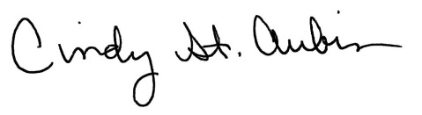
Cindy St. Aubin
World Mission Coordinator
cstaubin@gbdioc.org

