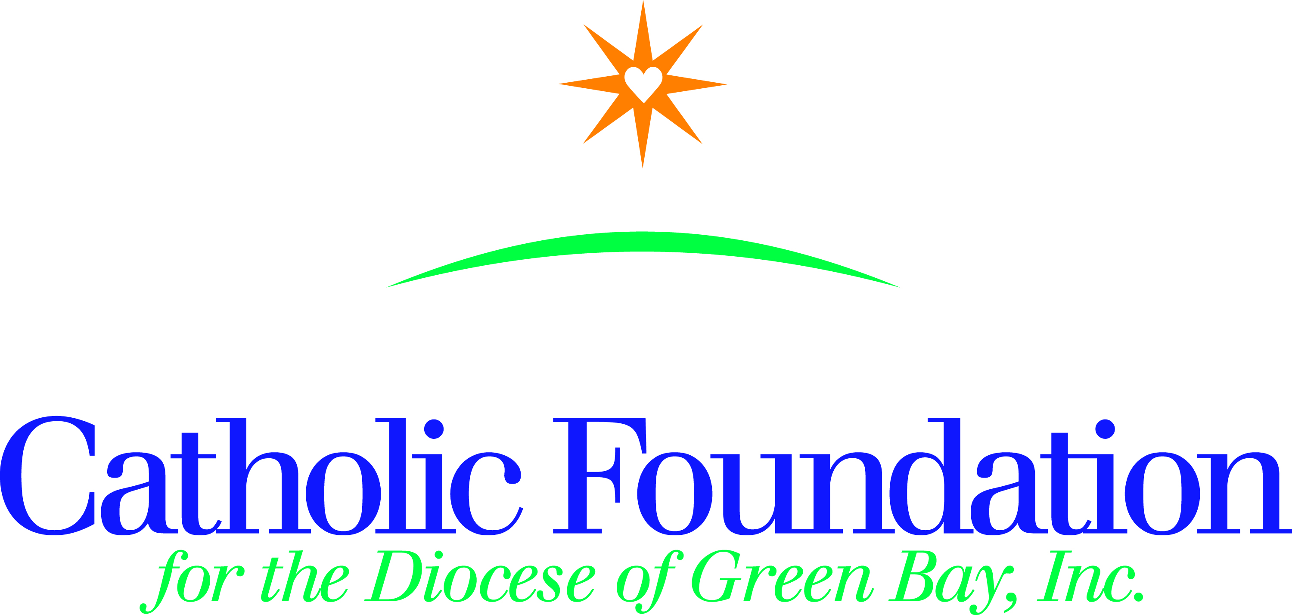

“Today, amid so much darkness, we need to see the light of hope and to
be men and women who bring hope to others.” Pope Francis

Dear Pastors,

Please consider for your bulletin the weekend of February 6-7.

Ash Wednesday, February 10, marks the beginning of Lent and the beginning of our own personal Lenten journey. To enrich your journey & make a difference in the lives of others, please consider the following resources.

Operation Rice Bowl (ORB)
In its 41st year, CRS Rice Bowl is Catholic Relief Services’ Lenten program for families and faith communities in the United Sates who want to put their faith into action. Participants are invited to hear stories about their brothers and sisters in need around the world, and devote their Lenten prayers, fasting and alms to change the lives of those who suffer in poverty.

Through the 40 days of Lent journey with a collection of daily reflections and activities include in the CRS Rice Bowl calendar and on the mobile app.

As always, 75% of your contribution to Operation Rice Bowl supports programs to help families and communities overcome the challenges of hunger and poverty. 25% remains in our diocese to support local hunger and poverty efforts.

World Mission Services Projects Booklet
The Projects booklet consists of 28 short term mission projects. Support a mission project and experience the needs of the global Church. It’s a way to be the hands of Christ. Perhaps you’ll buy a piglet, chicks or a cow for a school in Uganda, a bicycle for catechist in Tanzania, educate children internationally, or help feed children in Bolivia or the Philippines. Your support to the www.catholicfoundationgb.org/projects booklet gives the gift of hope for a better future.

However you prepare for Easter during your 40-day Lenten journey, may you see the light of hope and bring hope to others.

Respectfully,
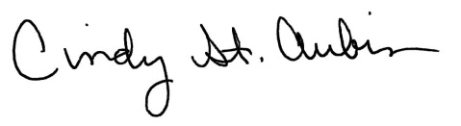
Cindy St. Aubin
World Mission Coordinator
cstaubin@gbdioc.org

