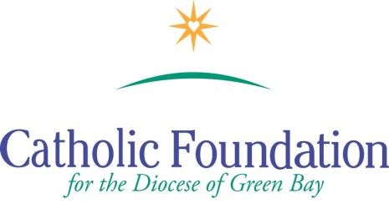

World Mission Sunday Appeal –October 22, 2017
Suggested Bulletin Announcements

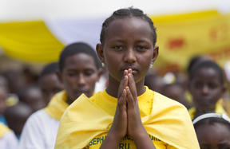

Week before the Collection
Next weekend we will celebrate World Mission Sunday and the mercy of God as we extend His loving heart to our neighbors half a world away. At Mass on Sunday, I invite you to have a special moment of encounter with the Pope’s missions throughout the world. Generously offer your talents, creativity, wisdom and experience to bring the message of God’s tenderness and compassion to the entire world. Please keep the Missions in your prayers and please be generous.
Weekend of World Mission Sunday
Today is World Mission Sunday. It is a day we recommit ourselves to our common vocation through Baptism, to be missionary disciples. Your prayers and generous gifts to the Society for the Propagation of the Faith, Latin America and Eastern Europe will help missionaries offer the poor of these areas practical help. The missionaries share the mercy of God and connect us with people in need around the world.

Weekend after World Mission Sunday

Thank you for your generosity of spirit and heart to the World Mission Sunday collection. As Pope Francis says “you enable the missionary heart of Christian communities to join in prayer, testimony of life and communion of goods, in responding to the vast and pressing needs of evangelization.” You are truly missionary disciples. We pray for blessings for you and your families.

