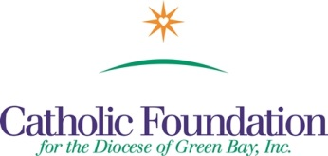
Bulletin Suggestions
Home Missions-Our Own Needs Collection – June 4, 2017
Strengthening the Church at Home

Home Missions-Our Own Needs Collection will take place on Pentecost Sunday, June 4, 2017 Your support of this appeal makes a difference in the lives of our brothers and sisters right here in the United States. The four major beneficiaries represented in the collection and their purpose are:

Catholic Communications Campaign develops media programming to promote Gospel values. Half of all proceeds raised stay in our Diocese. As people continue to access more information on mobile devices there is an increased need to provide Faith resources on these platforms as well. It provides grants to Catholic organizations to support televised Masses, and diocesan newspapers.

Catholic Home Missions Appeal assists over 80 Home Mission dioceses in the United States. They cannot provide basic Pastoral services without outside help. Basic services include Mass, the sacraments, and religious education. This Appeal helps to ease the struggle of these Dioceses and assist them to form vibrant faith communities.

Black and Native American Missions – exist to build Christion communities among the Native American, African American and Alaska Native people in the U.S. Every penny collected is given out in Diocesan grants to support pastoral ministry, Catholic schools, religious education programs where these communities exist. In our Diocese, we annually receive a grant from this collection to assist parishes in Neopit & Keshena in their outreach and service to Menominee Indian Tribe.

The Catholic University of America established by the Vatican and U.S. Bishops, located in Washington D.C. is the National University of the Catholic Church. It provides and education guided by Catholic tradition to nearly 7,000 students each year. One third of our U.S. Bishops are alumni, along with 12,400 priests. Every donated dollar supports financial aid for students. Your gift will enable Catholic University to expand its impact in preparing the next generation of leadership for our Church and Nation.

Please Give Generously

Thank you,
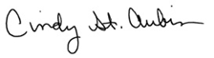
World Mission Coordinator

WE’RE ALL MISSIONARIES - WORLD MISSION SUNDAY, October 24, 2010

